**Introduction:**

This project aims to understand the prevalence of alcohol abuse among young adults in Oklahoma, specifically those aged 18-24. We will analyse data from the Behavioural Risk Factor Surveillance System (BRFSS) to identify patterns of alcohol consumption, geographical trends, and areas with the highest and lowest rates of abuse.

**Objectives**

1.Extract, transform, and load the data into a structured format for analysis.

2.Analyse adolescent alcohol abuse by city and county, focusing on respondents aged 18-24.

3.Calculate the average alcohol consumption by geographical region, highlighting areas with the highest and lowest consumption rates.

4.Provide valuable insights to inform policy decisions or interventions aimed at reducing alcohol abuse among young adults.

**Dataset Overview**

1.The BRFSS dataset contains information on:

Survey questions related to alcohol consumption.

Respondent demographics (age group, gender, location)

Geographical information (zip codes, cities, counties)

Survey responses indicating alcohol abuse.

We will focus on the 18-24 age group to understand patterns of adolescent alcohol consumption.

**Tools and Technologies**

SQL to create data structures, load the dataset, perform data transformation, and execute queries for analysis

MySQL Database to store and manage the data.

Microsoft Excel for preliminary data exploration and visualisation (if needed)

Data visualisation tools (optional) to create interactive charts and maps highlighting geographical patterns.

By combining SQL queries, database management, and data analysis techniques, we will provide meaningful insights into adolescent alcohol abuse in Oklahoma.

**Exploring BRFSS Data:**

The BRFSS table is composed of several key columns that provide valuable insights into health-related survey data. Here's a breakdown of each column:

Question: This column contains the specific survey questions asked to respondents, covering various health behaviours, risk factors, and conditions.

Response: This column captures the respondent's answer to the corresponding question, which can be categorical (e.g., "Yes" or "No") or predefined options.

Break_Out: This column identifies the subpopulation or group the respondent belongs to, such as age groups, gender, income levels, or other demographic factors.

Break_Out_Category: This column categorises the "Break_Out" value, such as "Age Group," "Income Level," "Education Level," or "Race."

Sample_Size: This column provides the number of individuals surveyed in each particular group, which is essential for determining the reliability and statistical significance of the survey results.

Data_Value: This column contains the numeric value representing the outcome of the survey response, such as the number of respondents who reported consuming alcohol within a certain period.

ZipCode: This column contains geographical information about where the respondent resides, allowing for location-based analysis and exploration of health behaviour trends in specific areas.

Key Uses of the Columns

Question and Response provide the foundation for understanding the survey content and behaviour being measured.

Break_Out and Break_Out_Category enable the segmentation of the population into meaningful subgroups for more detailed analysis.

Sample_Size and Data_Value offers quantitative measures to assess the scale of the behaviour or condition within the population.

ZipCode facilitates geographical analysis, allowing for a deeper understanding of how behaviours or risk factors vary by location.

By understanding the BRFSS table columns, you can unlock valuable insights into health-related survey data and gain a deeper understanding of the behaviours and trends within specific populations and geographic regions.

**Uncovering Patterns of Adolescent Alcohol Consumption**

In this analysis, I delved into the BRFSS data to understand the prevalence of adolescent alcohol consumption among individuals aged 18-24. Our goal was to identify the subset of responses where participants admitted to consuming alcohol, indicating a "Yes" response to alcohol-related questions.

**Key Variables Explored**

Question: Survey questions related to alcohol consumption, specifically targeting adolescent drinking behaviour.

Response: The response indicating whether the participant engages in alcohol consumption, with a focus on "Yes" responses.

Break_Out: Demographic breakdown of participants, concentrating on the 18-24 age group.

Sample_Size: Number of respondents surveyed in each demographic category.

Data_Value: Number of respondents who answered "Yes" to alcohol consumption.

Filtering for Adolescent Alcohol Consumption

To explore the survey responses, I filtered the dataset to include:

Age Group 18-24: Focusing on this demographic group to understand adolescent behaviour.

Response = "Yes": Indicating that the participant admitted to consuming alcohol.

Geographic Breakout: Analysing data at both the city and county levels to gain insights into regional differences in adolescent drinking behaviour.

Key Insights

My analysis revealed:

**Prevalence of Alcohol Use:** By filtering for "Yes" responses in the 18-24 age group, we identified the proportion of adolescents reporting alcohol use, highlighting distinct patterns across different cities and counties.

**City-Level Analysis:** Oklahoma City has the highest concentration of adolescents aged 18-24 who admitted to consuming alcohol.

County-Level Analysis: Countries with larger urban centres, like Oklahoma County, show higher levels of alcohol consumption among adolescents, while rural counties may have lower rates.

**Average Alcohol Use by ZipCode:** Calculating the average alcohol use by ZipCode provides a more granular view of the distribution of adolescent alcohol consumption across different regions.

Exploring survey responses related to adolescent alcohol consumption provides valuable insights into behavioural patterns within the 18-24 age group. By focusing on "Yes" responses, we can identify areas with higher or lower rates of alcohol use, informing public health strategies aimed at reducing underage drinking and its associated risks. Our analysis provides a foundation for understanding adolescent alcohol consumption and supports the development of targeted interventions.

**Identifying High-Risk Groups of Adolescents for Alcohol Abuse**

To pinpoint groups of adolescents at the highest risk for alcohol abuse in Oklahoma in 2009, we analysed the Behavioural Risk Factor Surveillance System (BRFSS) data. Our goal was to identify patterns of alcohol consumption among adolescents aged 18-24 who responded "Yes" to questions about alcohol use.

Methodology

Filtering for Relevant Data: Age Group 18-24 with "Yes" Responses

We began by extracting the relevant subset of data related to adolescent alcohol consumption. Specifically, I focused on:

**Age Group 18-24:** We filtered the data for participants aged 18-24, corresponding to adolescent individuals.

**Response = 'Yes':** We narrowed down the data to only those participants who responded "Yes" to alcohol consumption-related questions, indicating that they are consuming alcohol.

To achieve this, I used the following SQL query:

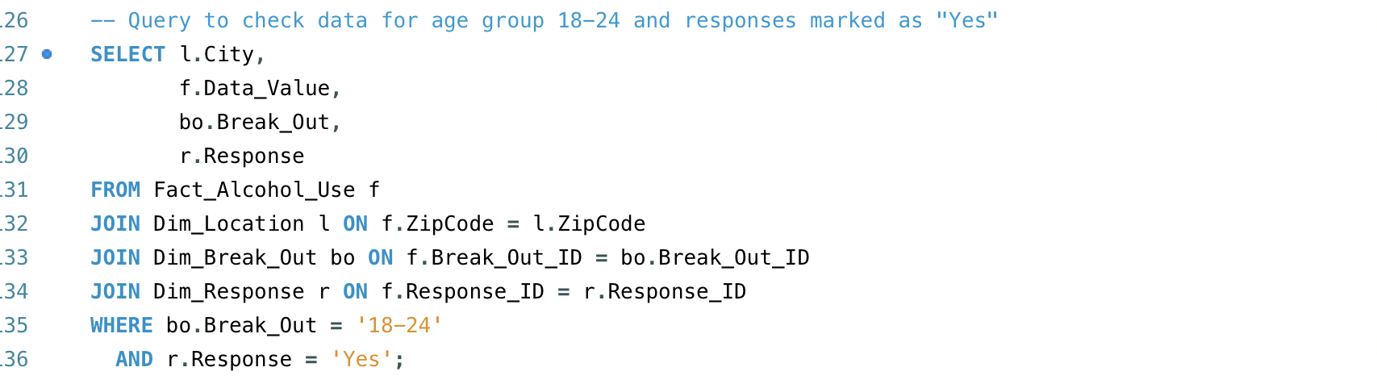

SELECT * FROM BRFSS WHERE Break_Out = '18-24' AND Response = 'Yes'

I also performed joins on the following tables to extract detailed information:

Dim_Location: To obtain location-specific data (city)

Dim_Break_Out: To access demographic breakdown information.

Dim_Response: To retrieve response type data.

By applying these filters and joins, we were able to isolate the data relevant to adolescent alcohol consumption and identify patterns of high-risk behaviour.

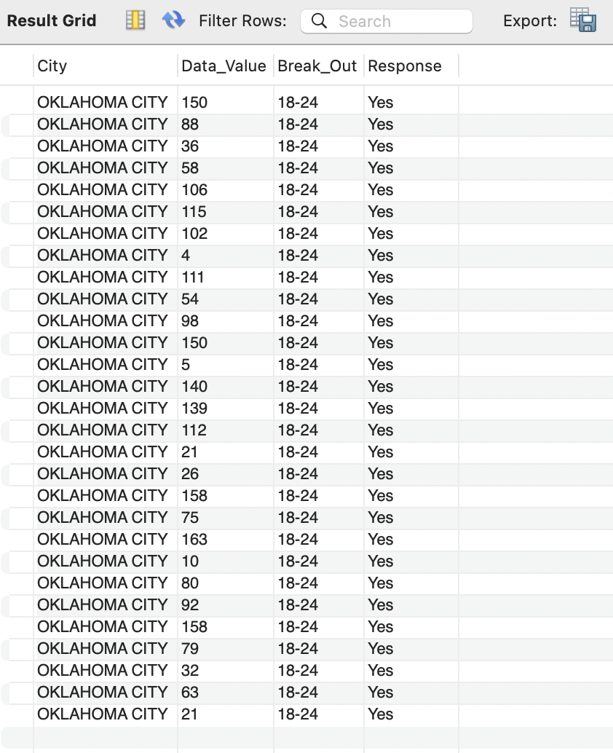

The query outputs the following key fields:

City: The city where the respondent lives.

Data_Value: The number of respondents from that city who answered "Yes" to alcohol consumption.

Break_Out: Indicates the demographic breakdown, which in this case is '18-24'.

Response: Indicates the response type, which is "Yes" for alcohol consumption.

This query helps identify which cities in Oklahoma have the highest numbers of adolescent alcohol users. The cities with the most significant counts of "Yes" responses can be flagged as high-risk areas.

**2. Calculating the Average Adolescent Alcohol Consumption by ZipCode**

The next step involves determining the average alcohol consumption by ZipCode. This helps us identify geographic areas where alcohol use is most prevalent among adolescents. By calculating the average alcohol use for each ZipCode, we can focus on the areas with the highest averages, which are likely to have adolescents at higher risk for alcohol abuse.

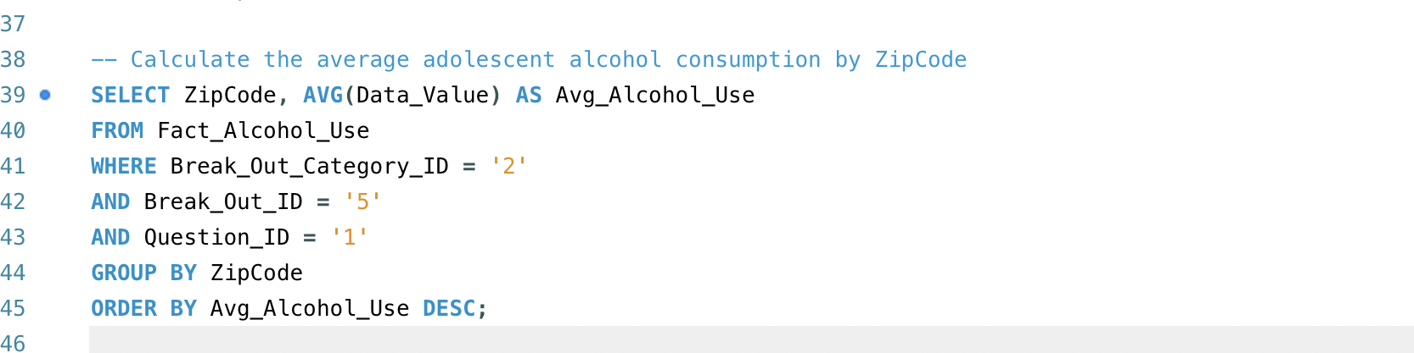

Explanation:

AVG(Data_Value): We calculate the average number of "Yes" responses for each ZipCode, representing the average alcohol consumption among adolescents in that area.

Break_Out_Category_ID = '2': This filters the data for the specific category of interest, which is age group-related information.

Break_Out_ID = '5': This is used to further filter the data specifically for the 18-24 age group.

Question_ID = '1': Filters the data to the specific question related to alcohol use.

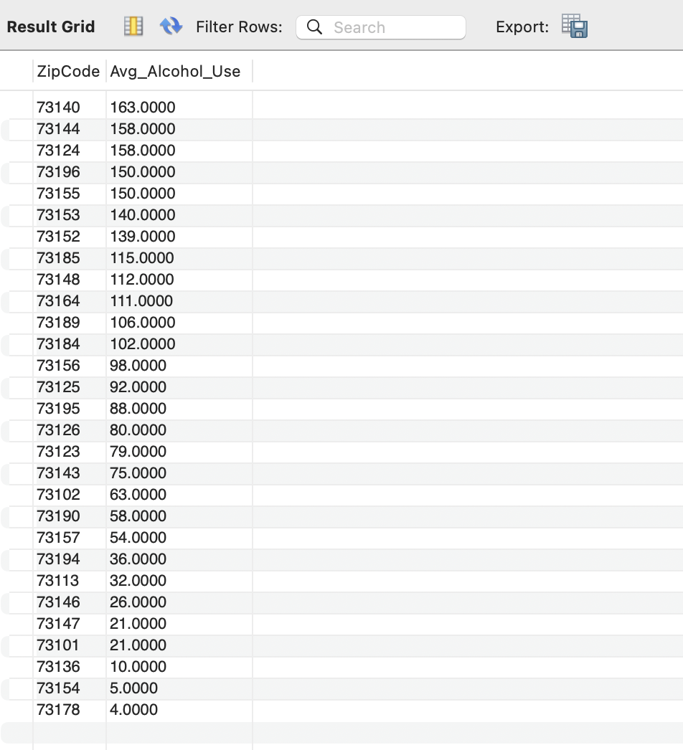

Output Explanation:

ZipCode: The geographic area (ZipCode) being analysed.

Avg_Alcohol_Use: The calculated average of alcohol consumption (based on the number of "Yes" responses) for each ZipCode.

This output provides a ranked list of ZipCodes, ordered by the average alcohol consumption among adolescents. The areas with the highest average alcohol use can be flagged as high-risk zones for underage drinking, and these areas may require targeted public health interventions.

**Interpreting the Results:** Uncovering High-Risk Areas for Adolescent Alcohol Abuse

Our analysis reveals valuable insights into the cities and ZipCodes in Oklahoma where adolescent alcohol consumption is most prevalent.

City-Level Insights

The first query highlights the cities in Oklahoma with the highest number of adolescents (18-24) who admitted to alcohol use. By examining the data, we can identify cities with the most significant "Yes" responses, indicating high-risk areas for adolescent alcohol abuse. This information can inform targeted strategies to reduce alcohol consumption among youth in these cities.

ZipCode-Level Analysis

The second query takes a more granular approach, identifying specific ZipCodes where adolescent alcohol consumption is most prevalent. By calculating the average alcohol use for each ZipCode, we gain a deeper understanding of which geographic areas are most affected. ZipCodes with higher averages indicate that a larger portion of the adolescent population in those areas is at risk for alcohol abuse.

Key Takeaways

Cities with high "Yes" response rates for adolescent alcohol use can be identified as high-risk areas.

ZipCodes with higher average alcohol use rates indicate a greater proportion of adolescents at risk for alcohol abuse.

These insights can inform localized strategies to reduce alcohol consumption among youth in high-risk areas.

By analyzing the data at both the city and ZipCode levels, we can develop a more comprehensive understanding of adolescent alcohol abuse in Oklahoma and create targeted interventions to address this critical public health issue.

**Creating Fact Table for Oklahoma_Alcohol_Use_DB:**

Step 1:

I began by using the ERDPlus tool to set up the Entity-Relationship Diagram (ERD) for the database. I selected the "Star Schema" design to reflect a clear and organised structure. The schema was named "OKLAHOMA" to indicate the specific focus of the data analysis, which is adolescent alcohol consumption in Oklahoma. This step set the foundation for defining the relationships between the different tables that will be used in the analysis.

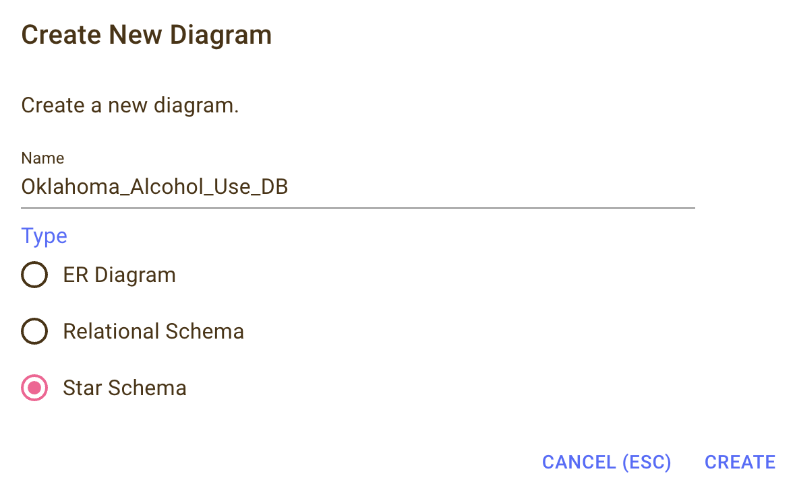

Step 2:

Next, I chose the "Fact" option in ERDPlus, which allowed me to create the central fact table for the analysis. This table will store the quantitative data (such as sample size and alcohol consumption values). I named this table FACT_ALCOHOL_USE to align with the focus of the analysis on alcohol use data.

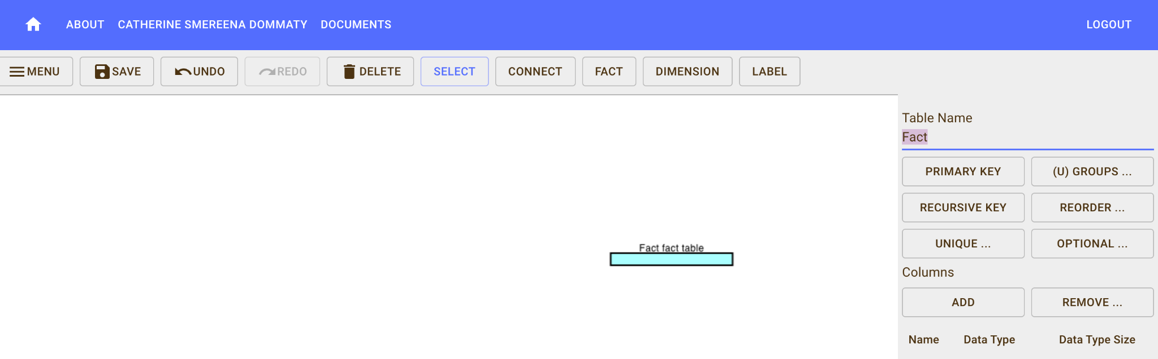

Step 3:

Once the fact table was created, I added the necessary fields by selecting the "Add" option in the ERDPlus tool. The key fields added to the FACT_ALCOHOL_USE table included:

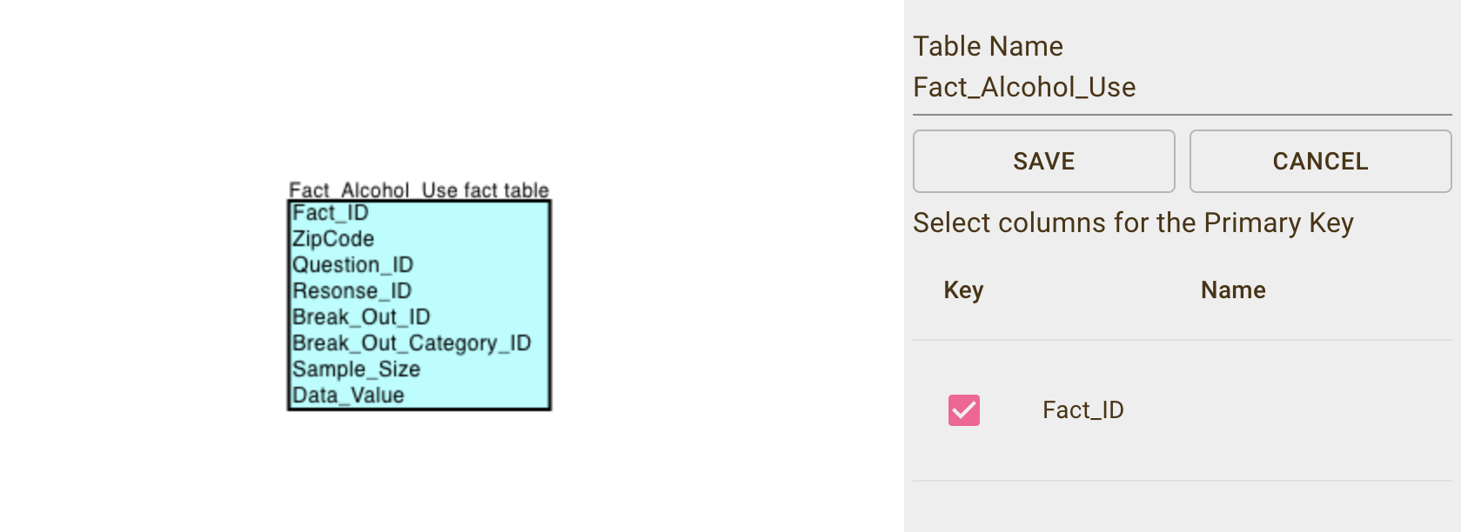

Fact_ID: A unique identifier for each record in the fact table.

Sample_Size: The total number of participants surveyed for each category.

Data_Value: The number of respondents who admitted to alcohol consumption, which is the main quantitative measure for this analysis.

This step completed the setup of the fact table, which is central to the analysis of adolescent alcohol use in Oklahoma.

**Creating Dimension Tables for Oklahoma_Alcohol_Use_DB:**

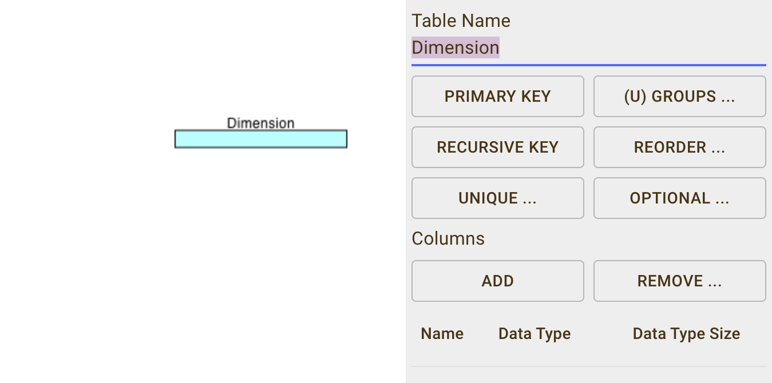

Step 1:

After creating the fact table, I moved on to creating the dimension tables. These tables were designed to store qualitative data such as survey questions, responses, demographic categories, and location information. The first-dimension table I created was Dim_Question, which holds the questions from the BRFSS dataset related to alcohol use.

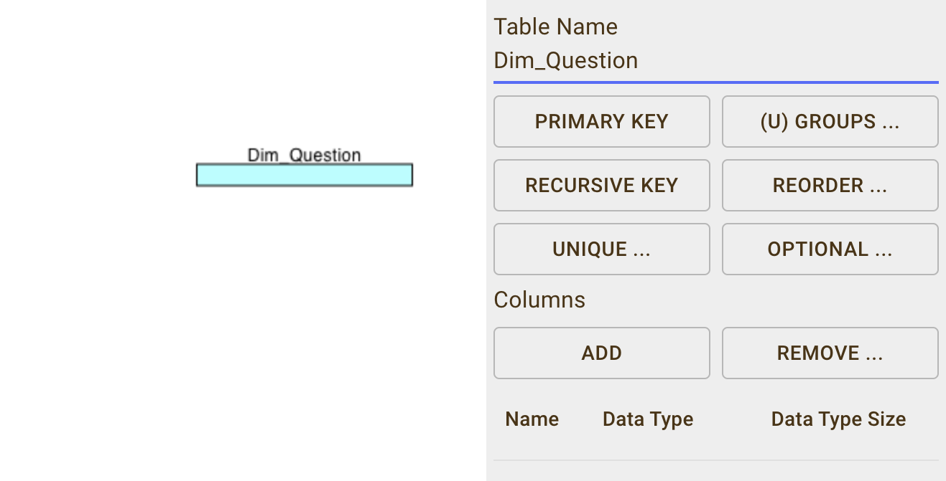

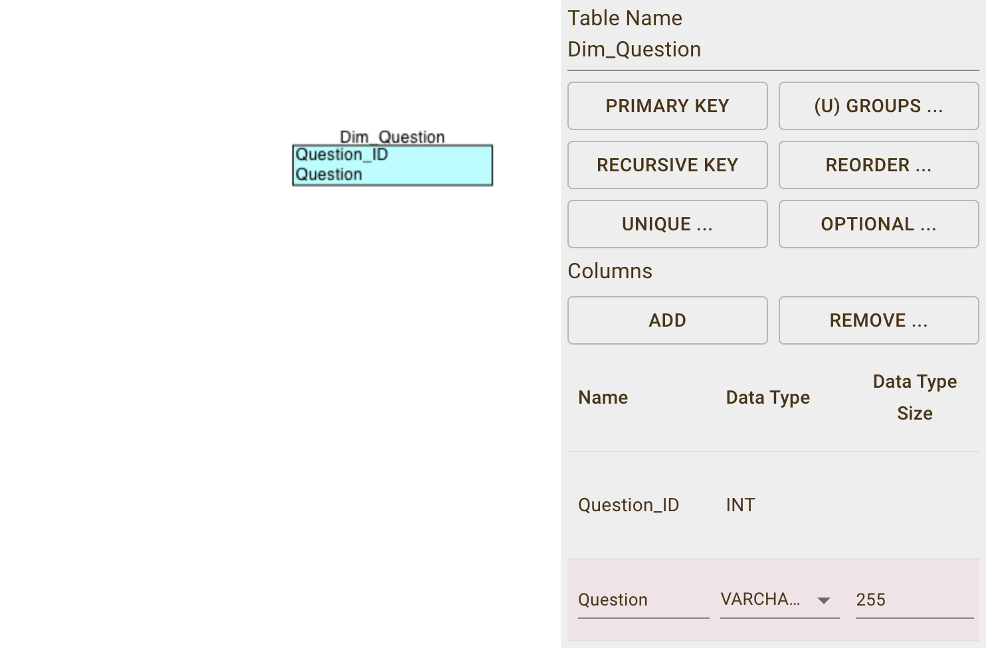

Step 2:

Next, I created the Dim_Response table. This table stores the possible responses to the survey questions, such as "Yes" or "No." This dimension table allows for easy filtering of the survey data based on the participants' answers.

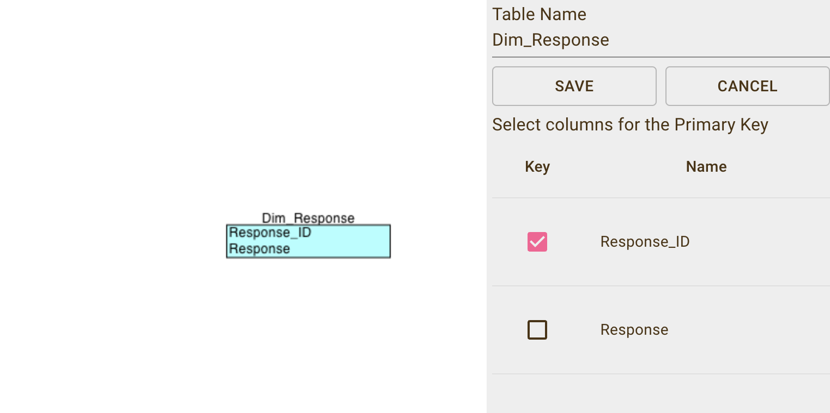

Step 3:

I then moved on to create the Dim_Location table, which stores geographic information such as ZipCode, City, and County. These fields will help identify the geographic areas where alcohol use is most prevalent among adolescents.

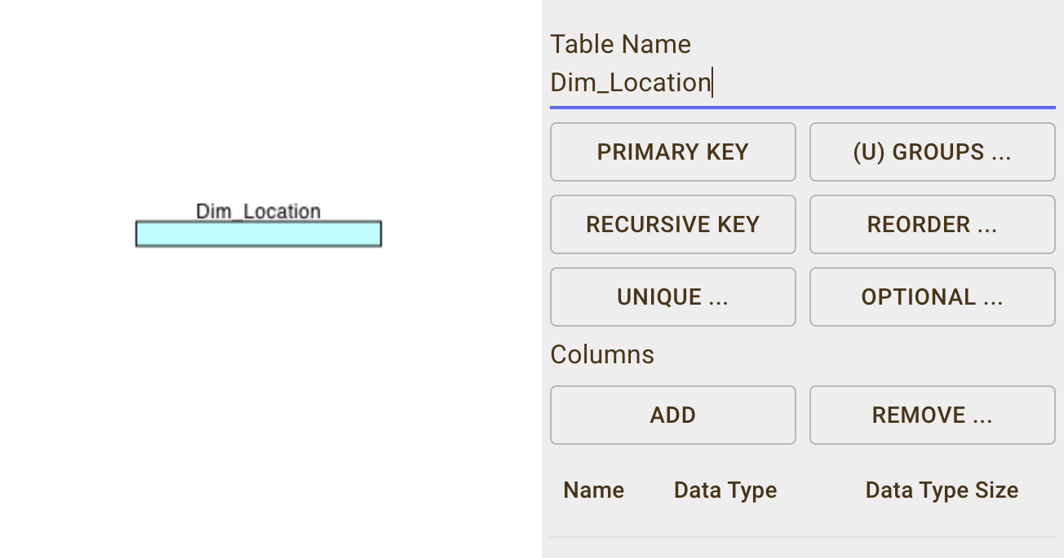

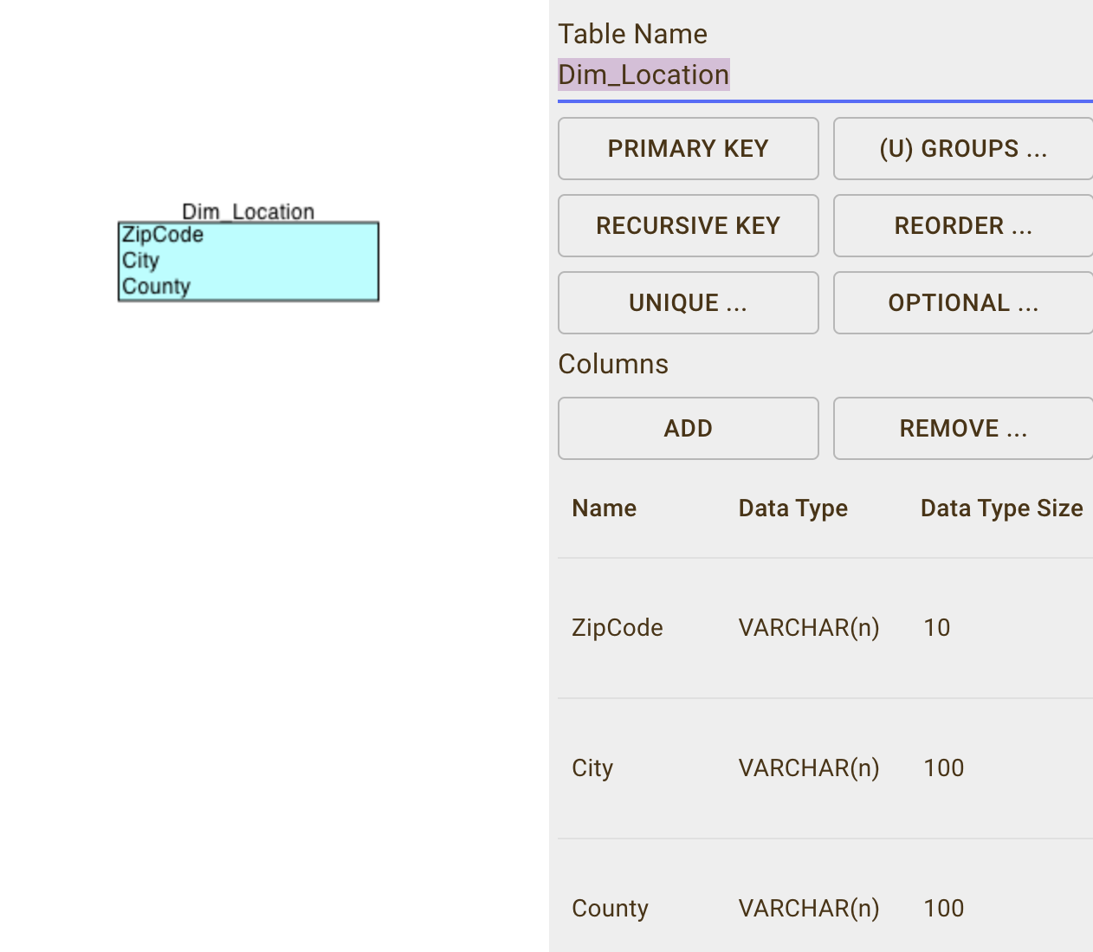

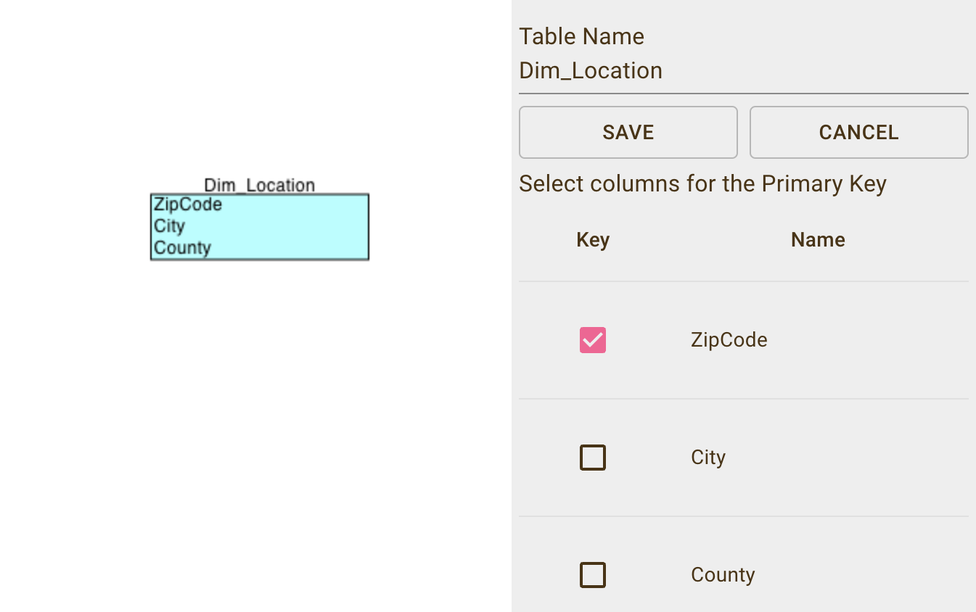

Step 4:

The final two-dimension tables created were Dim_Break_Out and Dim_Break_Out_Category. The Dim_Break_Out table stores demographic breakdowns such as age groups, while the Dim_Break_Out_Category table holds additional demographic categories that help categorise the respondents.

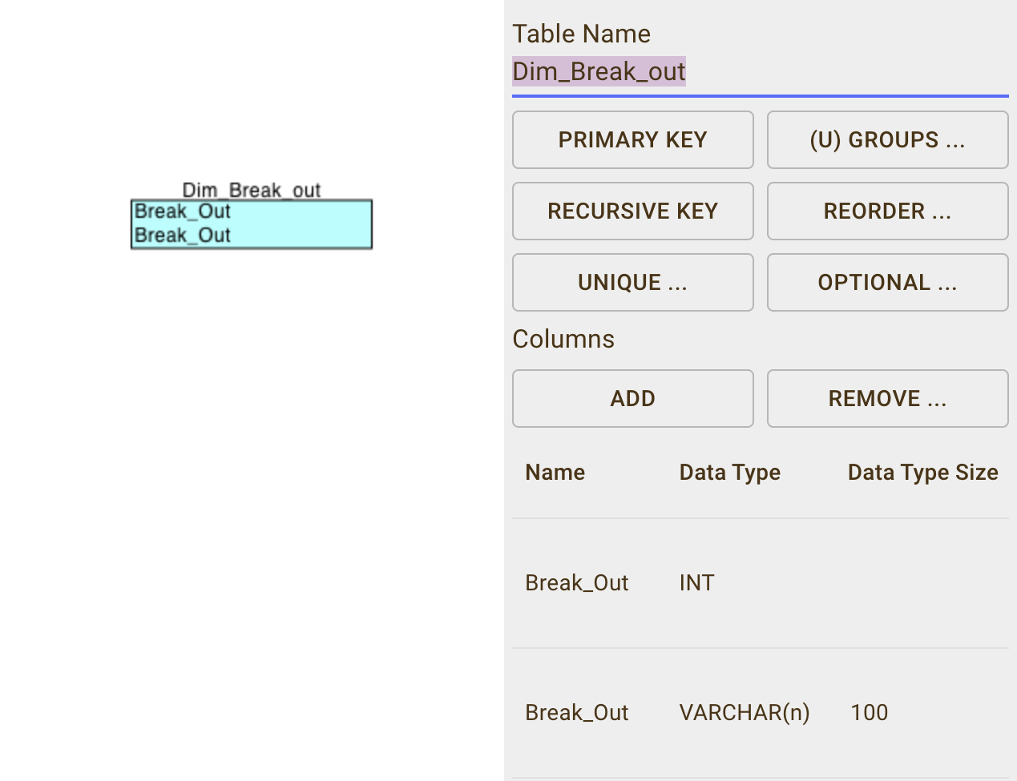

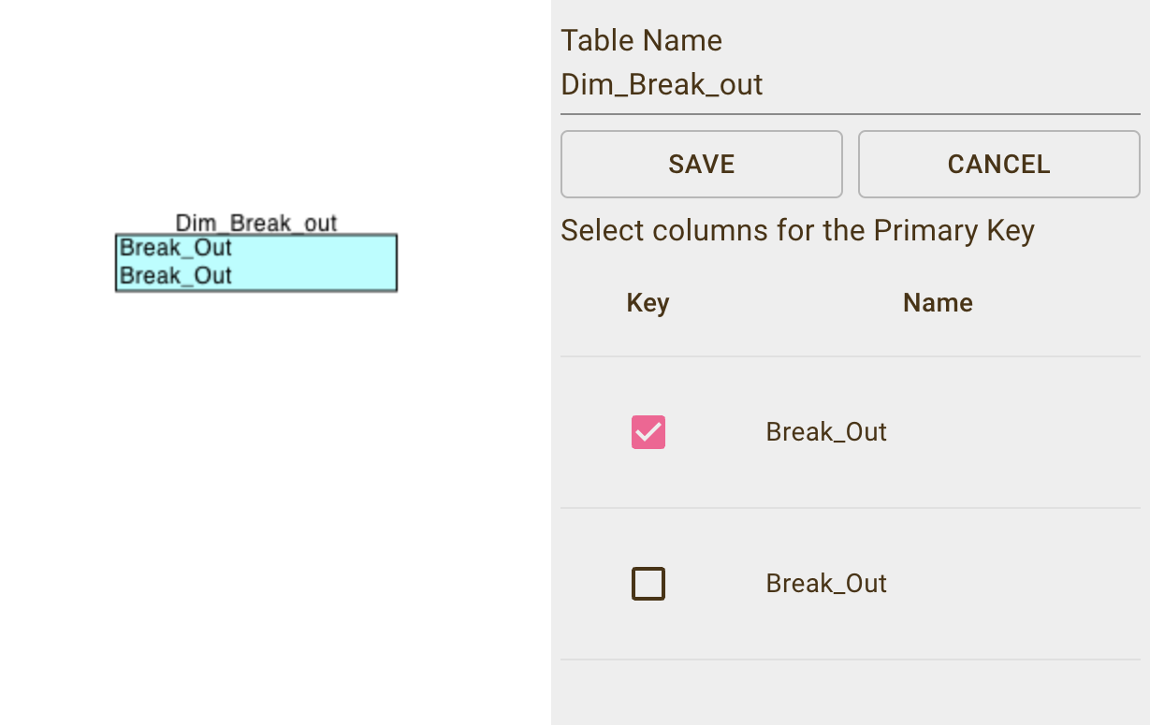

Step 5:

The Dim_Break_Out table stores demographic breakdowns such as age groups.

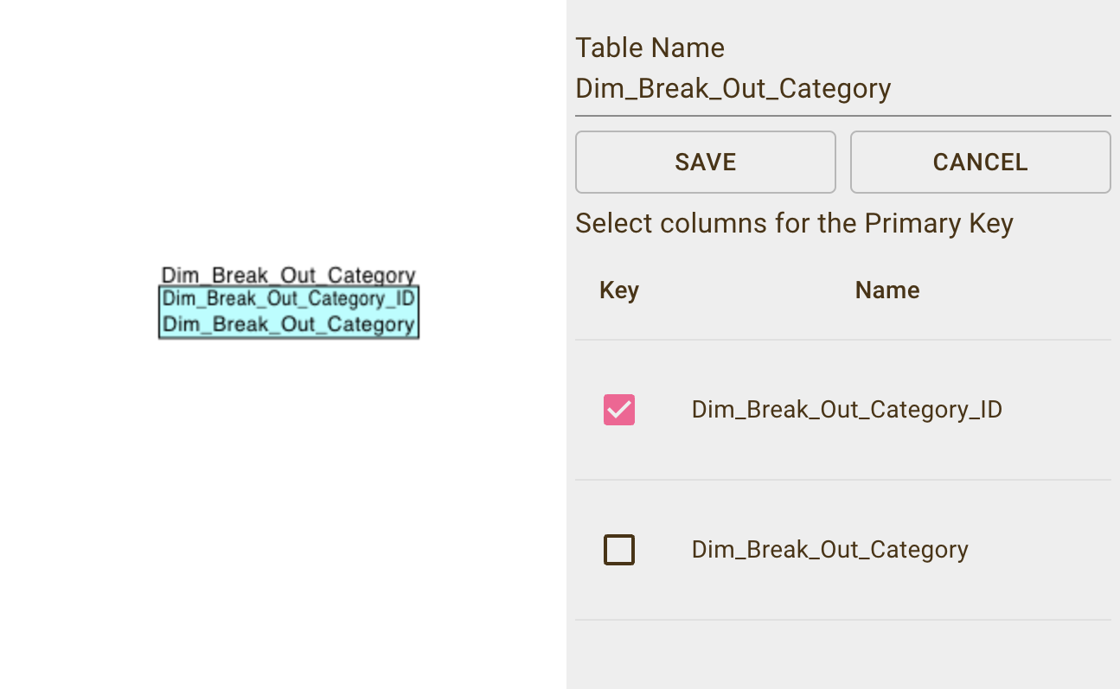

The ERD below represents the star schema design for the Oklahoma_Alcohol_Use_DB, with the Fact_Alcohol_Use table at the center, surrounded by related dimension tables. Each dimension table is linked to the fact table via foreign keys, enabling efficient querying and analysis of adolescent alcohol use data in Oklahoma.

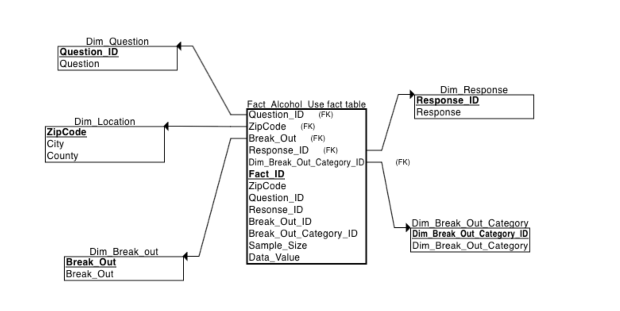

Fact Table: Fact_Alcohol_Use

The Fact_Alcohol_Use table is the central table where quantitative data related to alcohol consumption is stored. It includes fields like:

Fact_ID

Sample_Size

Data_Value

These fields capture key metrics for analysis, such as the number of respondents, sample size, and data values.

**Dimension Tables**

The following dimension tables are linked to the Fact_Alcohol_Use table via foreign keys:

Dim_Break_Out: Linked via Break_Out_ID, this dimension table stores demographic data such as age groups (e.g., 18-24). This relationship enables the analysis of alcohol use among different demographic groups.

Dim_Break_Out_Category: Connected via Break_Out_Category_ID, this table provides additional classification of the demographic data stored in the Dim_Break_Out table. For example, it can further group the breakout data by income, education, or other social categories.

Dim_Question: Linked via Question_ID, this table contains the specific survey questions from the BRFSS dataset related to alcohol consumption. This relationship allows for detailed analysis of the responses based on the exact question.

Dim_Response: Linked via Response_ID, this dimension table holds the participants' responses to the questions in the Dim_Question table. For example, it includes responses like "Yes" or "No" to alcohol use.

Dim_Location: Connected via ZipCode, this table stores geographic information such as City and County. It enables the analysis of alcohol use data based on the respondent's location.

Benefits of the Star Schema Design

The star schema design supports efficient querying and analysis of adolescent alcohol use data in Oklahoma by:

Enabling flexible analysis of alcohol use across different dimensions like age, location, and responses

Allowing for detailed analysis of the responses based on the exact question.

Enabling the analysis of alcohol use data based on the respondent's location.

Providing a granular breakdown of the population by demographic groups and social categories

This design facilitates the identification of high-risk adolescent populations and supports the development of targeted interventions to reduce alcohol consumption among youth in Oklahoma.

**Step-by-Step Process:**

Step 1: Creating the Database

I began the process by creating the database named Oklahoma_Alcohol_Use_DB. This is the main repository where all tables related to the assignment will reside. Creating a separate database ensures that the data is organised and structured properly for further analysis.

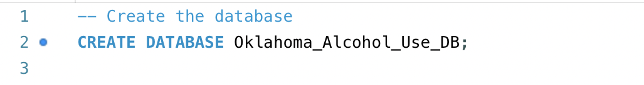

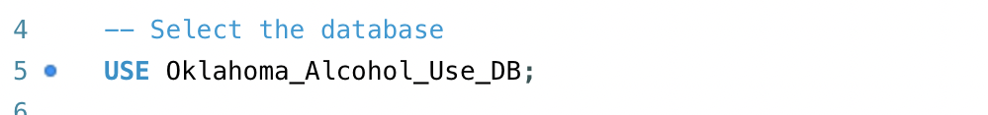

This step sets up the environment where all subsequent tables and queries will be executed, centralising the data related to the analysis of adolescent alcohol consumption in Oklahoma.

**Step 2: Creating the BRFSS_OK Table (Staging Table)**

The next step involved creating a staging table for the BRFSS (Behavioral Risk Factor Surveillance System) data, named BRFSS_OK. This table is used to store raw data directly from the dataset before transforming it into a more structured format.

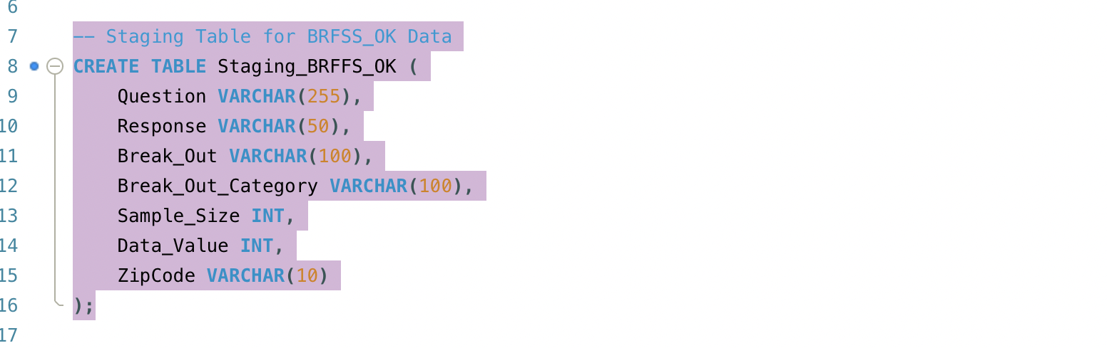

The staging table captures the raw data as it is, which can be later cleaned and normalised. This step allows me to prepare the data for further analysis.

Step 3: Data Import for BRFSS_OK

After creating the BRFSS_OK staging table, the next step was to import the raw BRFSS dataset into the table. The BRFSS data contains information on survey questions, responses, and demographic details, which are essential for analysing alcohol use in adolescents.

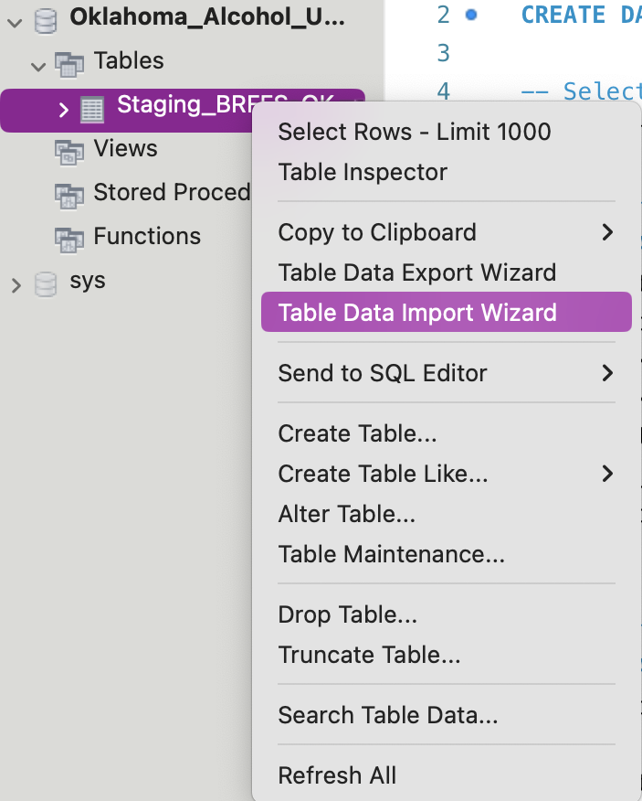

I then imported the data into the BRFSS_OK table by right-clicking on the table in MySQL Workbench and choosing the Data Import Wizard option.

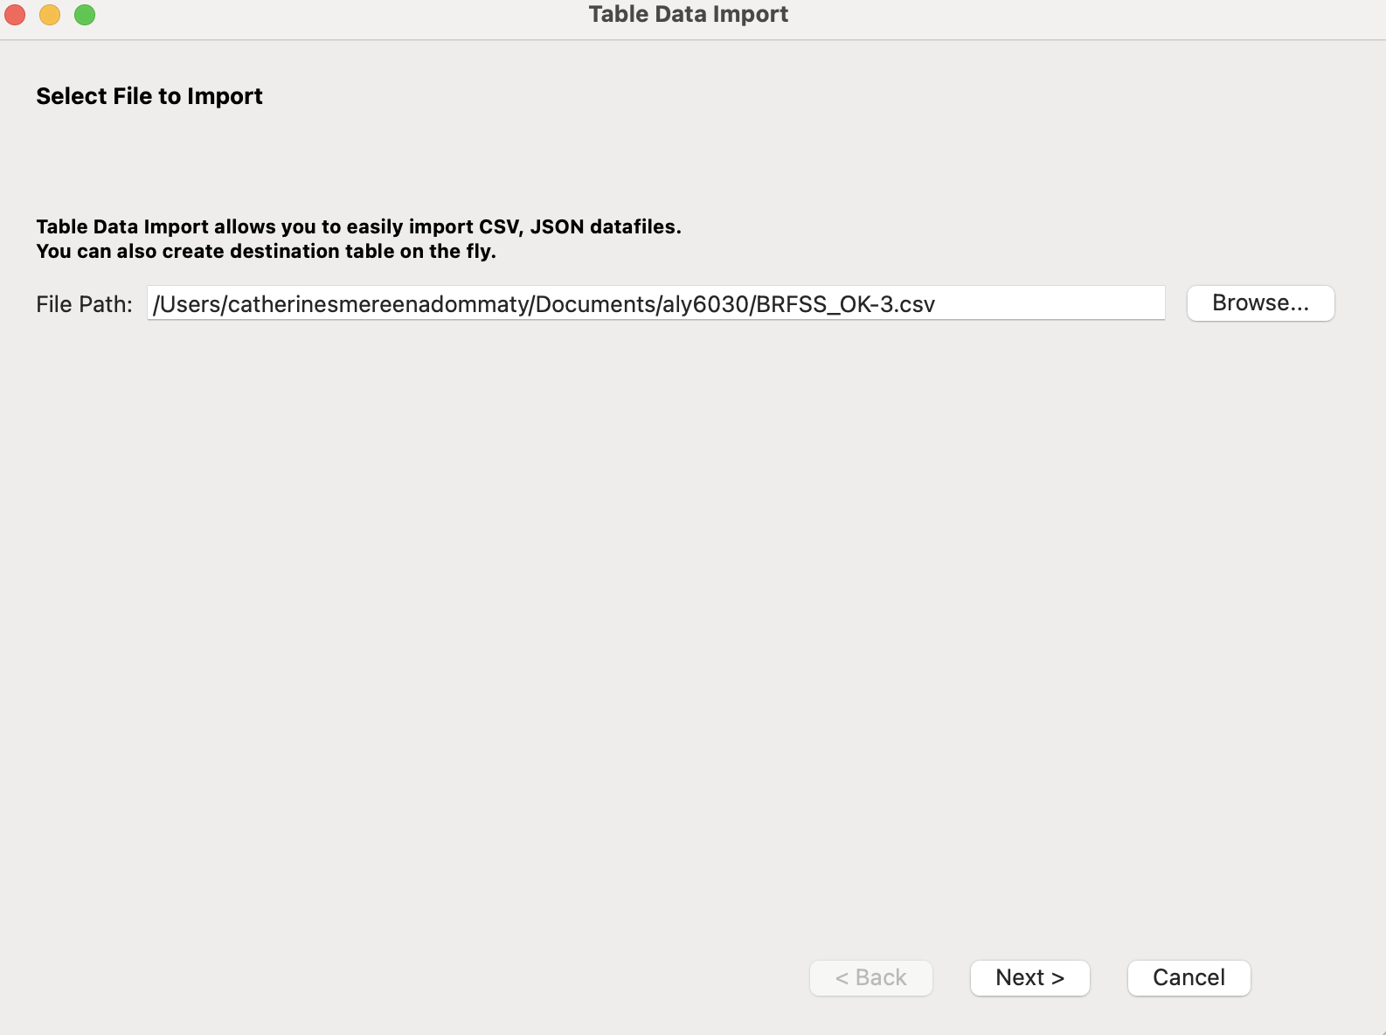

Step 4

After selecting the Data Import Wizard, I clicked Browse and navigated to the BRFSS-OK-3.csv file that I had prepared for the assignment. This file contains the raw BRFSS survey data that captures alcohol use, responses, and demographic breakdowns.

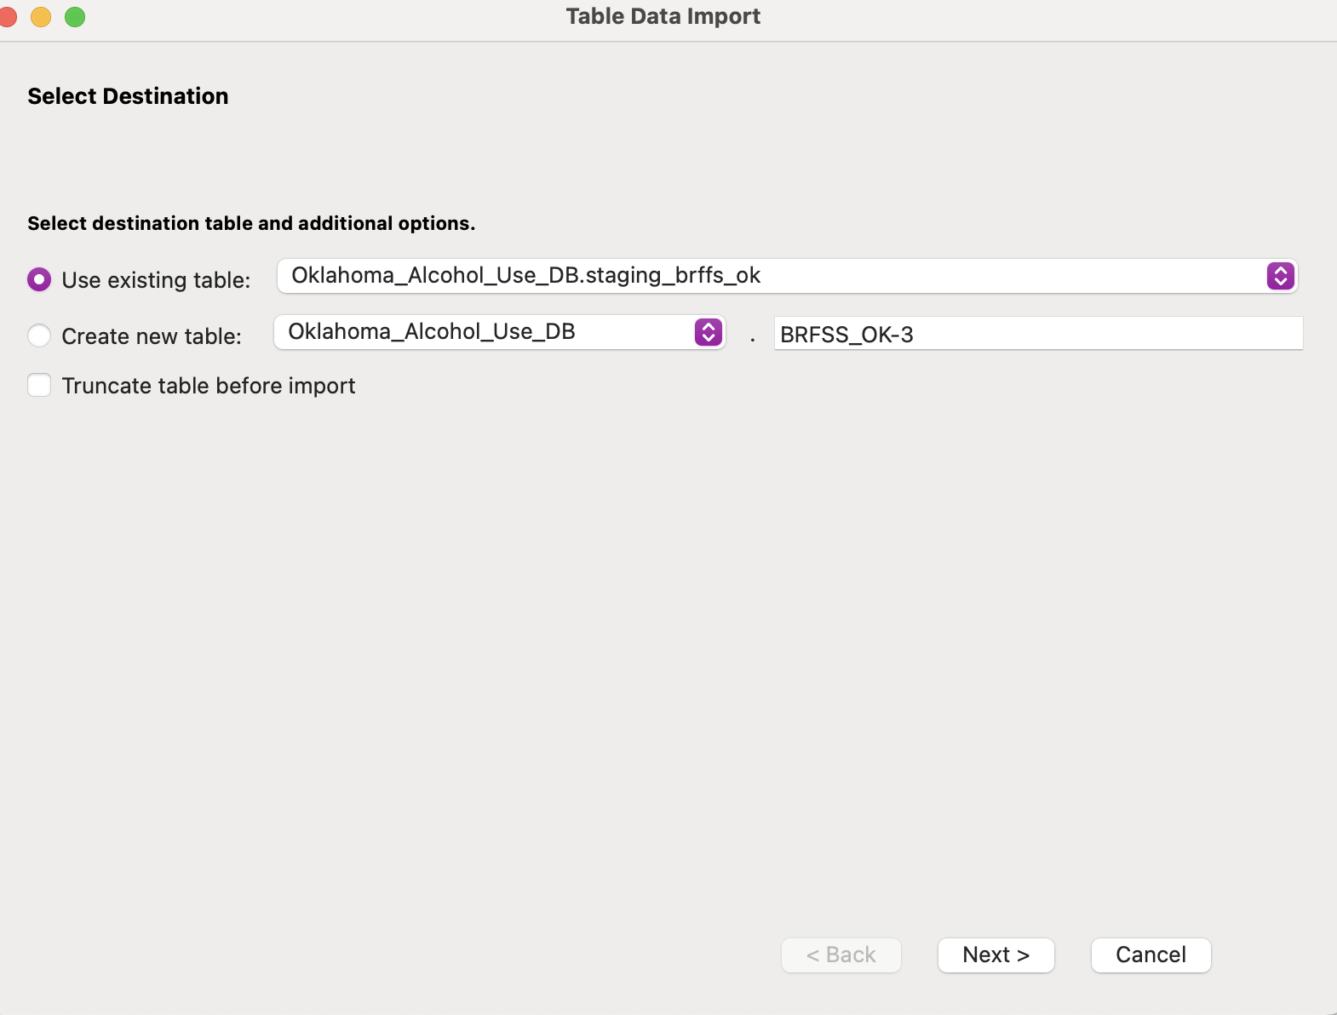

Step 5:

I selected the Use Existing Table option in the Data Import Wizard to ensure that the data would be imported into the already created BRFSS_OK table in MySQL.

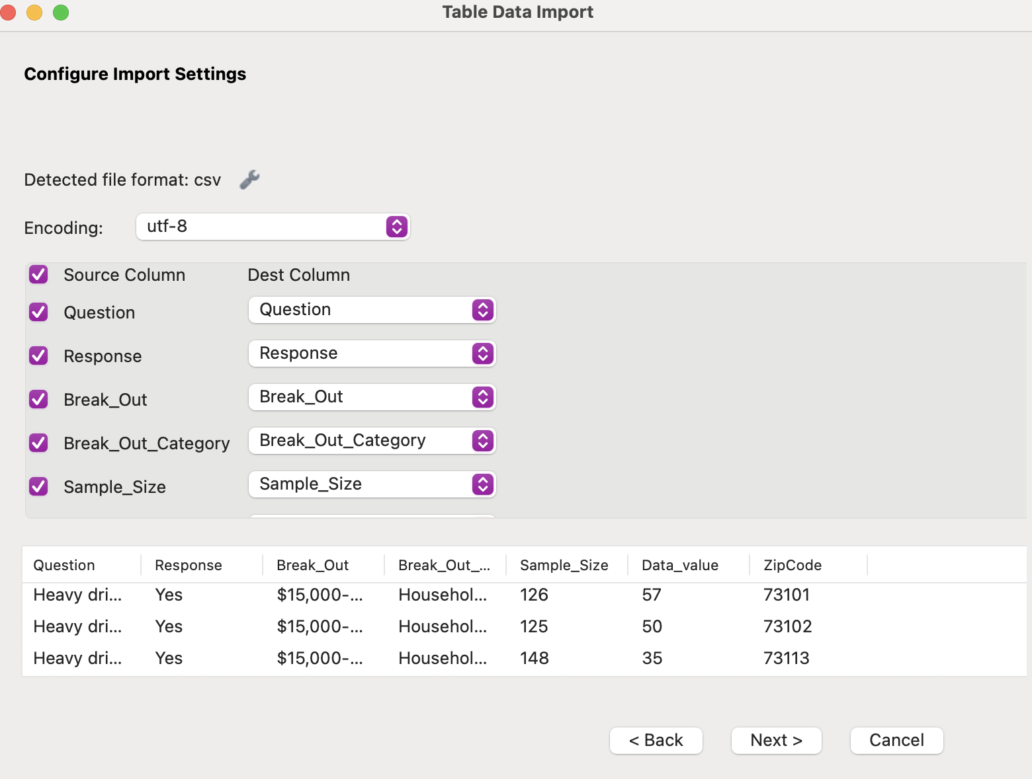

Step 6:

During the import process, I mapped each column in the CSV file to its respective column in the BRFSS_OK table. For example, the "Question" column in the CSV was mapped to the Question column in the database, the "Response" column to the Response field, and so on. I carefully reviewed these mappings to avoid errors.

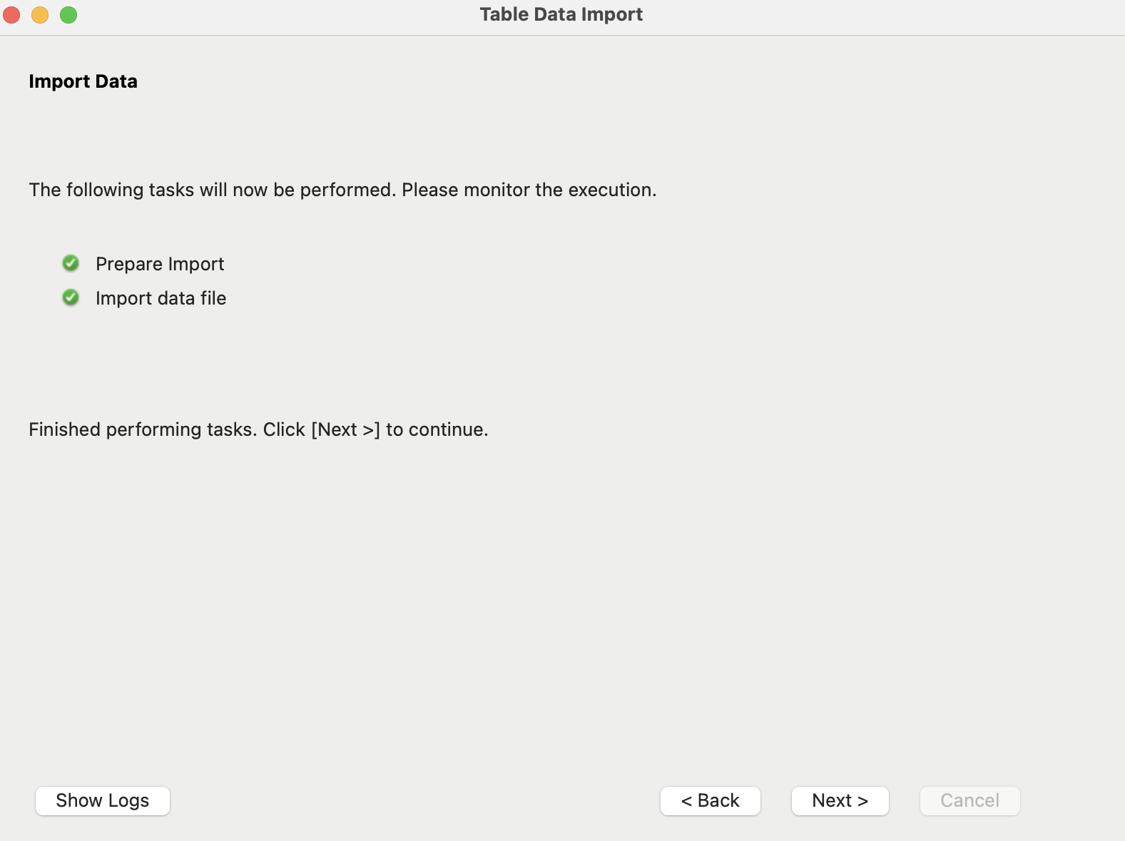

Step 7:

Once I verified that all column mappings were correct, I clicked Next to proceed with the data import process. MySQL Workbench processed the CSV file and inserted the data into the BRFSS_OK table.



Step 8:

After the import process was completed, I checked the BRFSS_OK table to ensure that the data was loaded correctly. I used the SELECT query to view the first few rows and verify the data integrity.

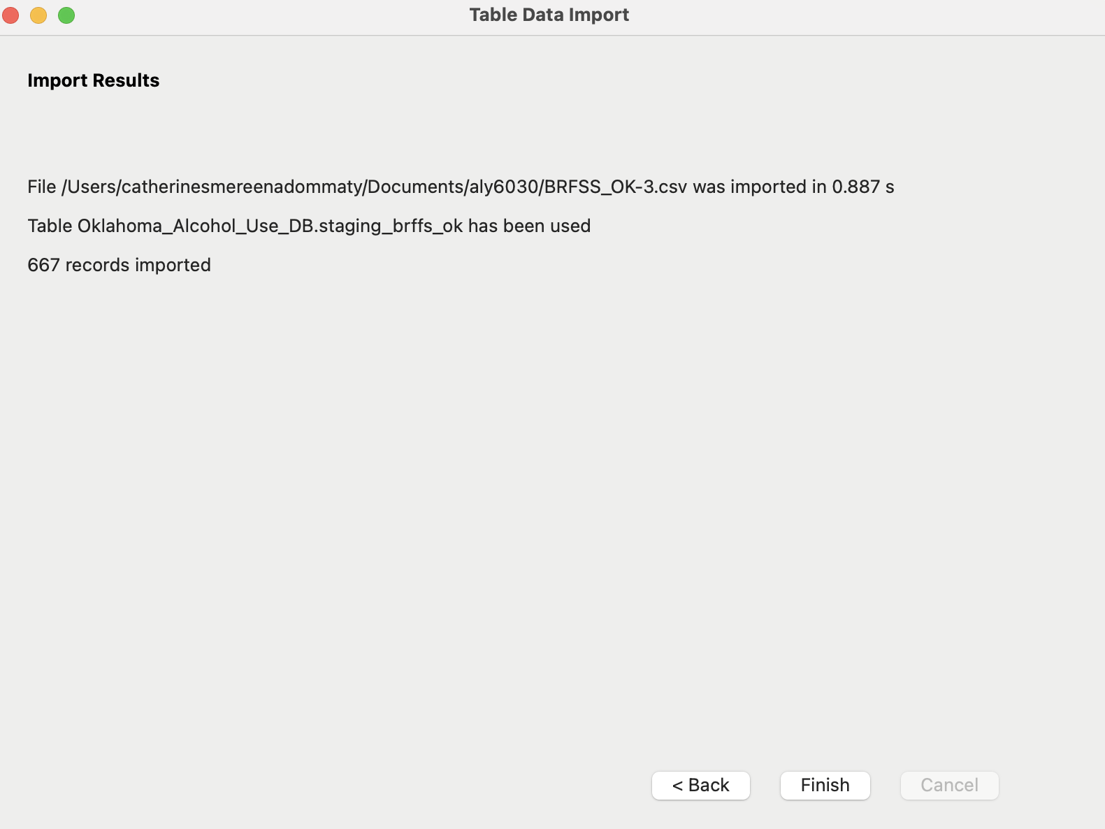

I confirmed that 667 records were successfully imported into the BRFSS_OK table.

**Creating the Demographics Staging Table (Oklahoma)**

I then created another staging table, Demographics_OK, which is used to store demographic information related to Oklahoma, such as ZipCode, City, and County.

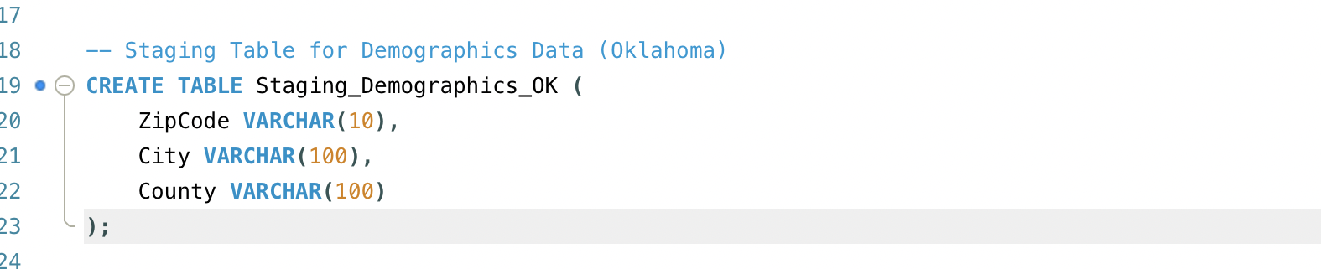

This table helps in capturing and organising location-based data, which is essential for geographic analysis of alcohol consumption in Oklahoma.

**Data Import for Demographics Table**

Step1:

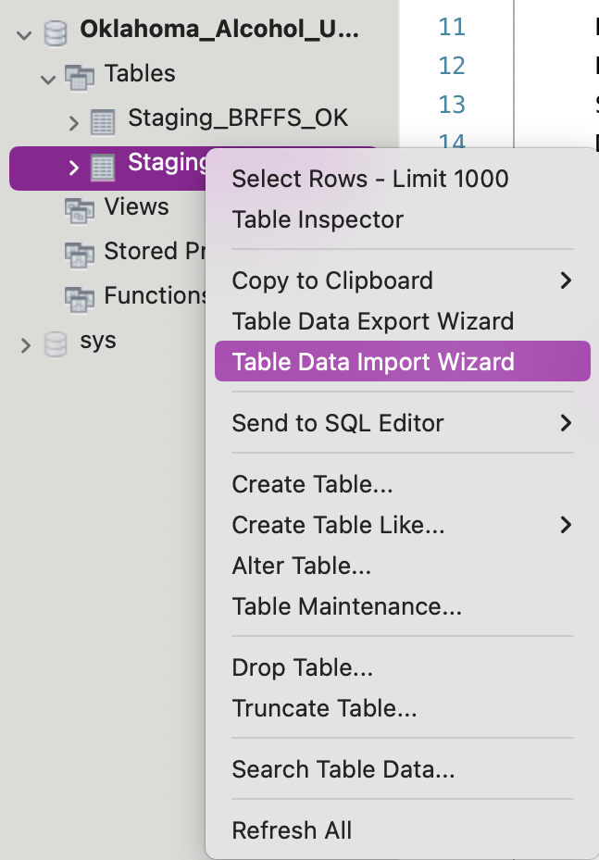

Next, I set up the Demographics_OK table to hold geographic information such as ZipCode, City, and County. I then repeated the import process by right-clicking on the Demographics_OK table and selecting the Data Import Wizard option.

Step2.

I clicked Browse to select the Demographics-OK.csv file, which contains the demographic data for Oklahoma.

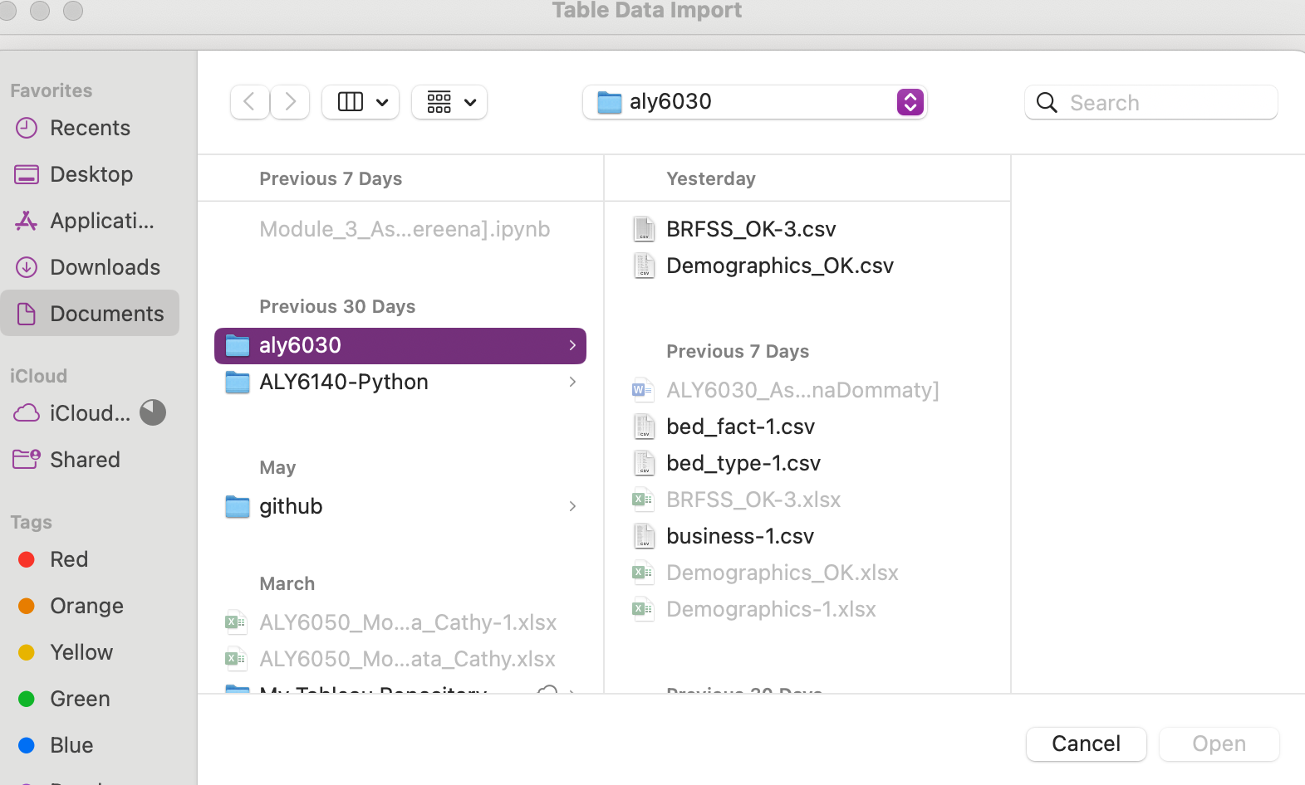

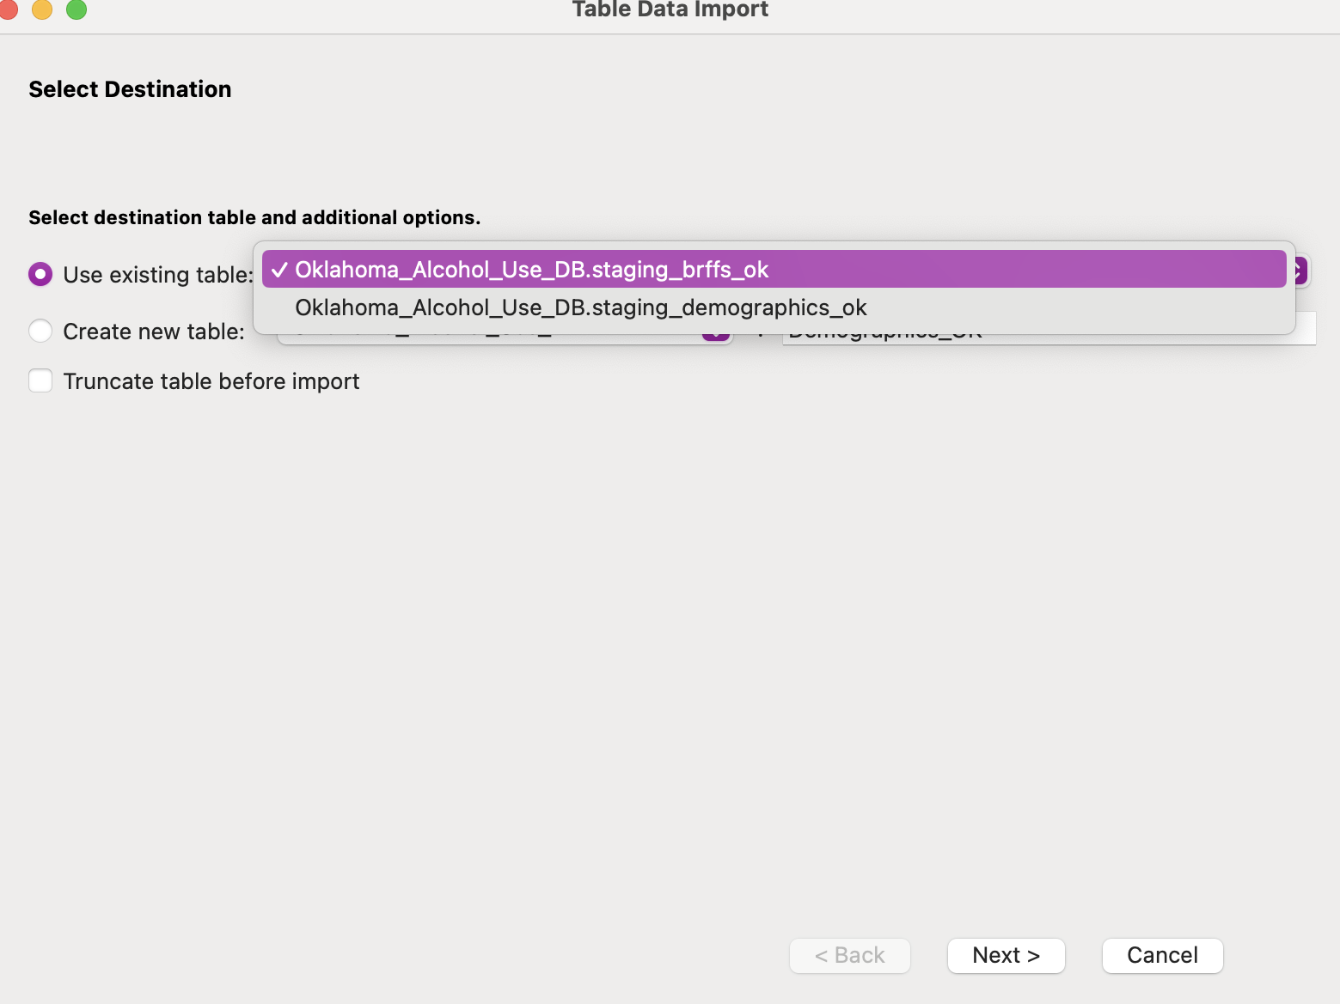

Step3:

As with the previous import, I selected the Use Existing Table option to ensure that the data would be inserted into the Demographics_OK table that had been created earlier in MySQL.

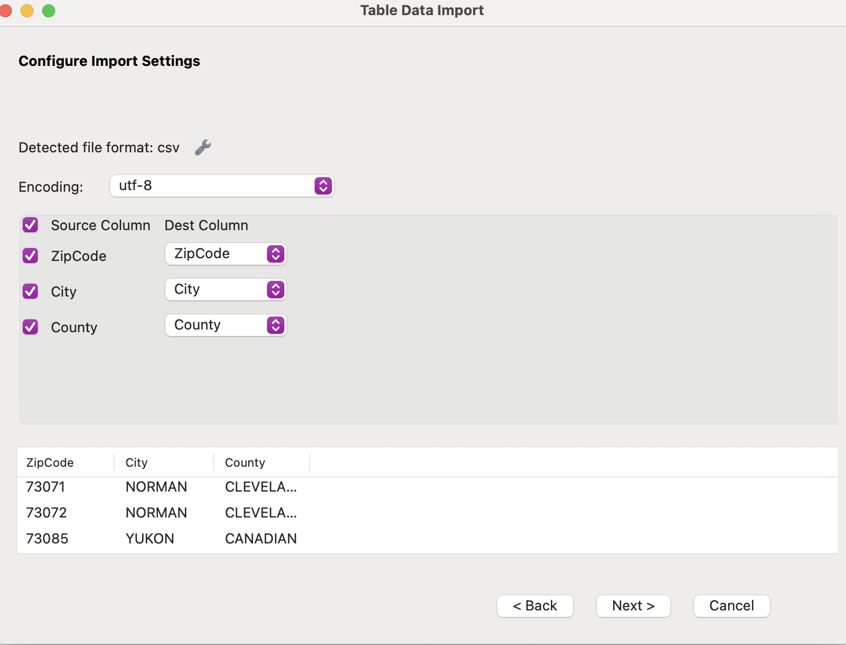

Step4:

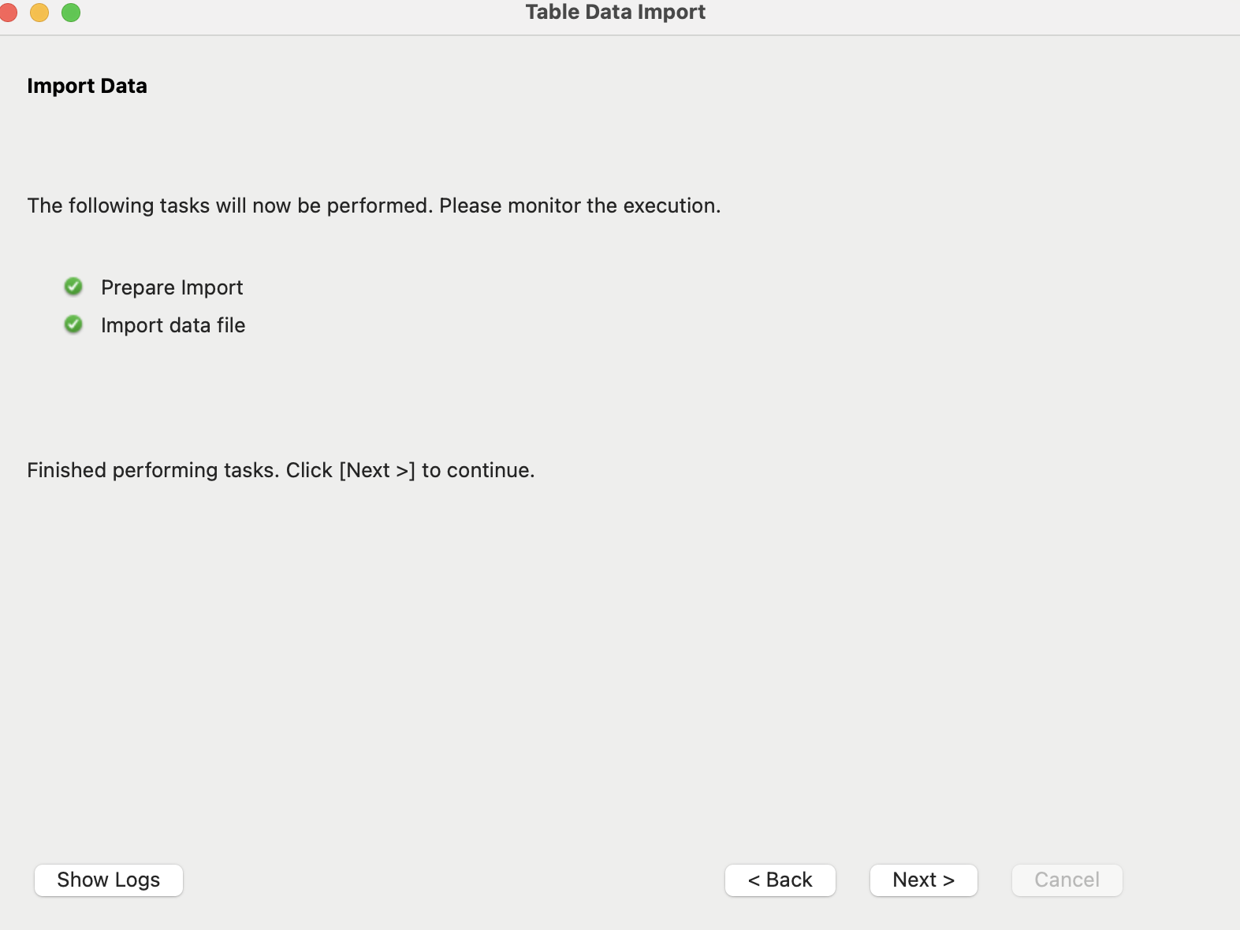

During the mapping process, I carefully matched each column in the Demographics-OK.csv file to its corresponding column in the Demographics_OK table. For example, I mapped the ZipCode column in the CSV file to the ZipCode field in the table and so on.

Step5:

Once the mappings were verified, I clicked Next to begin the import process. MySQL Workbench processed the file and inserted the data into the Demographics_OK table.

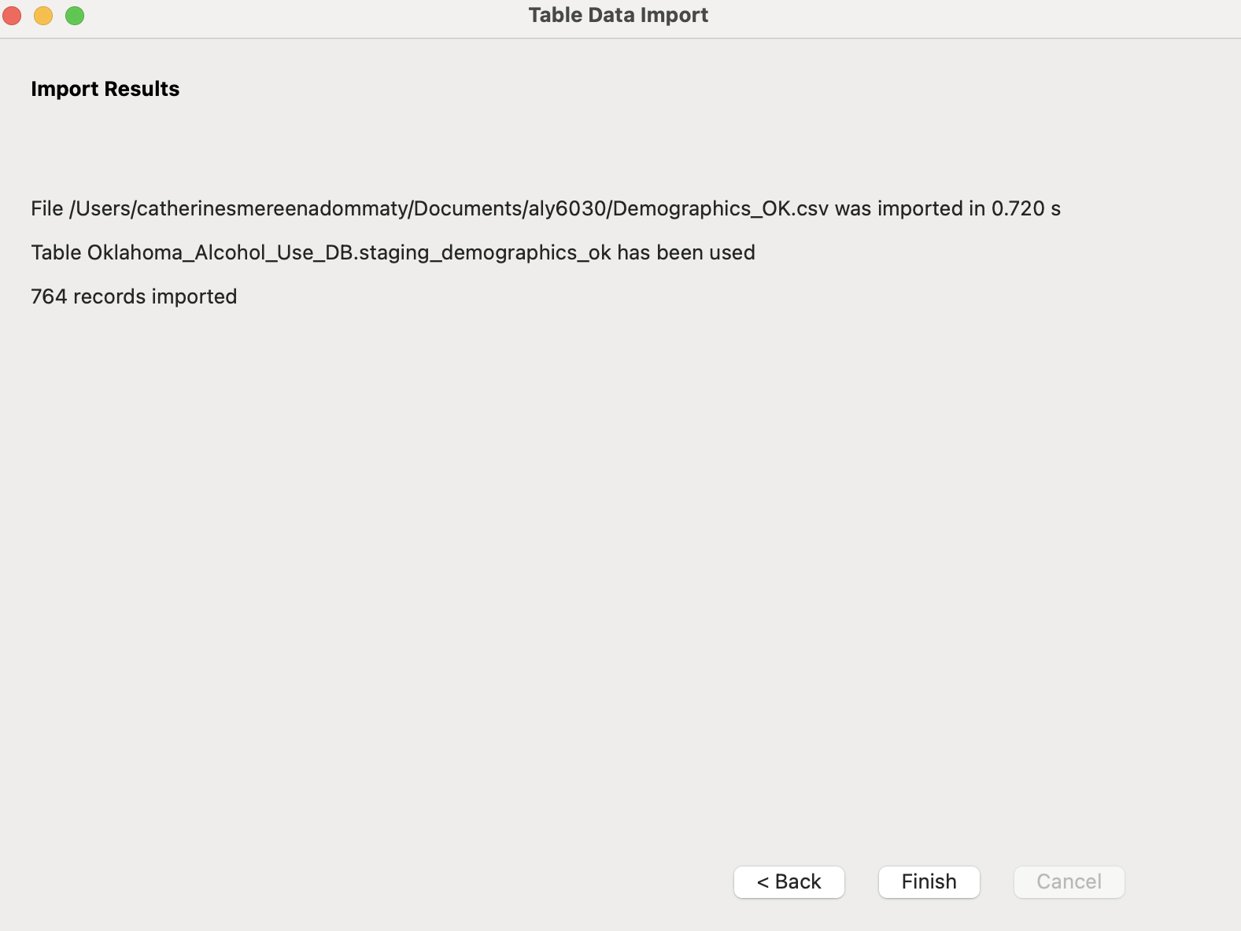

After the data was imported, I verified that 764 records were successfully loaded into the Demographics_OK table. A simple SELECT query was used to check that the data appeared correctly.

**Creating the Staging_Demographics_1 Table**

I began by creating the Staging_Demographics_1 table to hold raw demographic data from the BRFSS survey. This table is designed to store geographic information such as ZipCode, City, and County for later use in analysis.

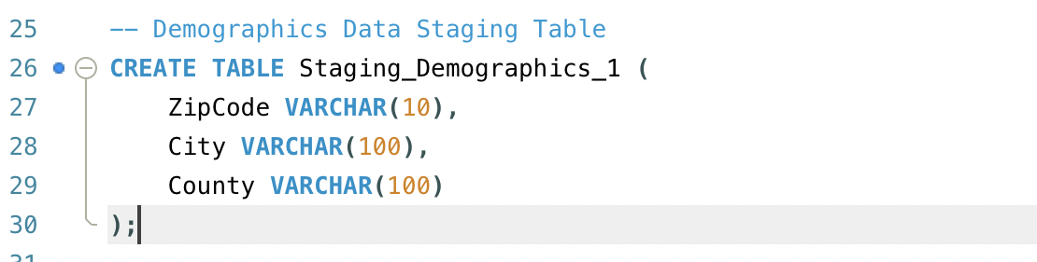

This table serves as a staging area for demographic data related to the locations where alcohol consumption patterns are being analysed. By creating a separate table, the raw data can be cleaned and transformed before populating the dimension tables for further analysis.

Importing Data into Staging_Demographics_1 Table

Step1:

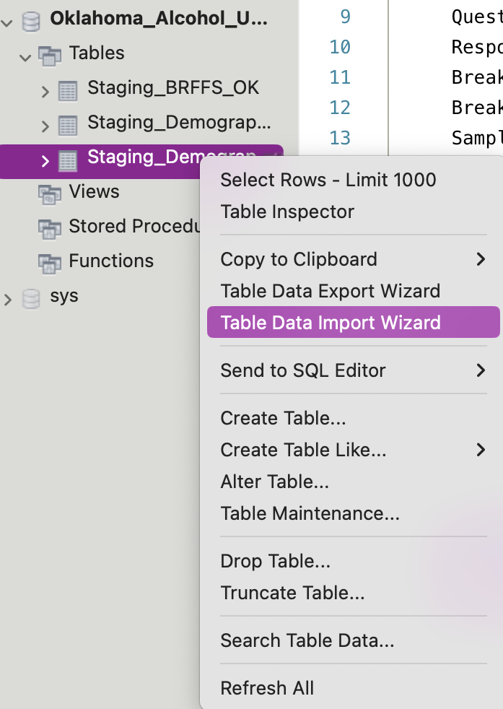

With the Staging_Demographics_1 table created; the next step was to import the demographic data into the table using the MySQL Workbench Data Import Wizard.

Right-click on the Staging_Demographics_1 table and select the Data Import Wizard option from the context menu.

Step2:

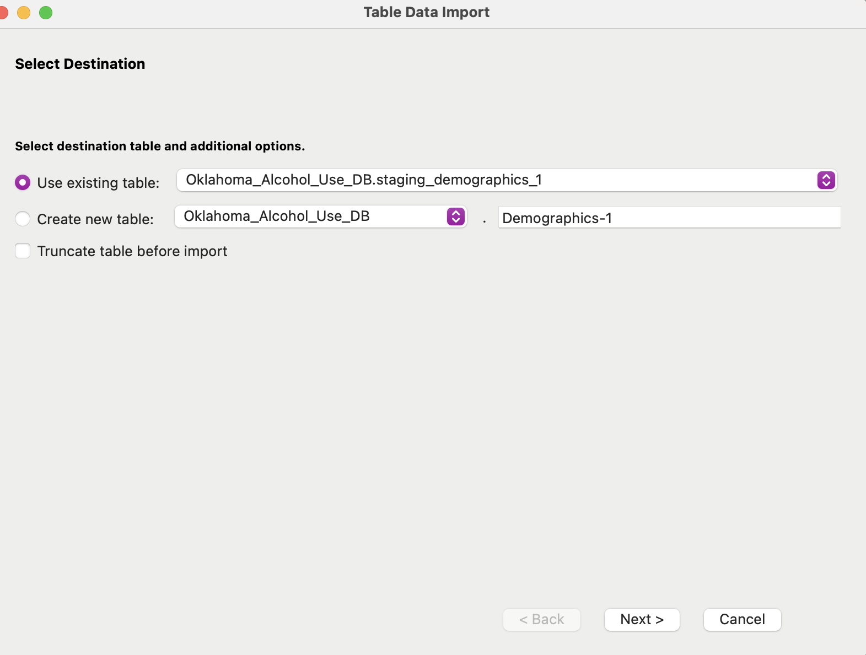

After selecting the CSV file, I chose the Use Existing Table option in the Data Import Wizard. This ensures that the data from the Demographics-1.csv file is imported directly into the pre-existing Staging_Demographics_1 table that I had created earlier.

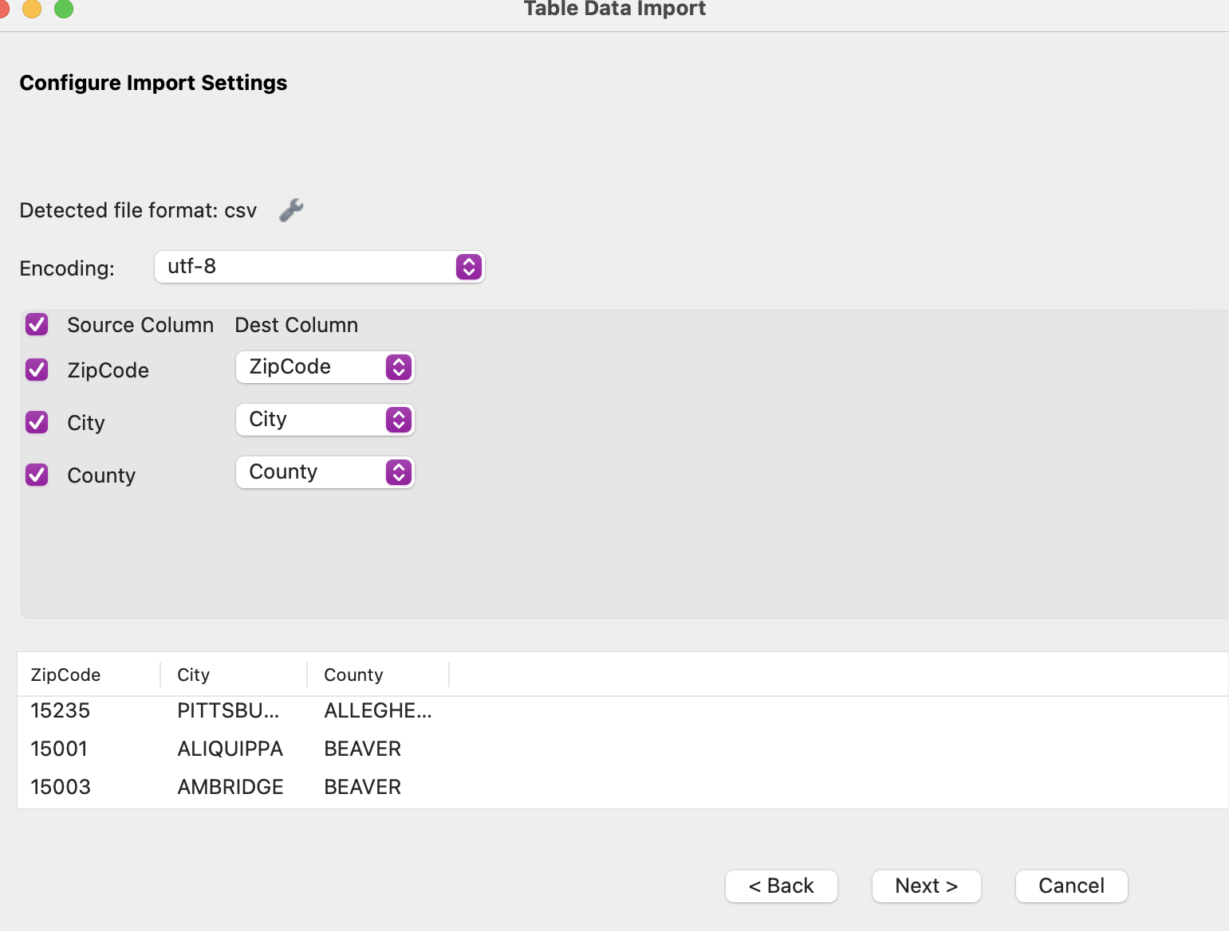

Step3: After reviewing and confirming that the mappings were correct, I clicked Next to start the data import process.

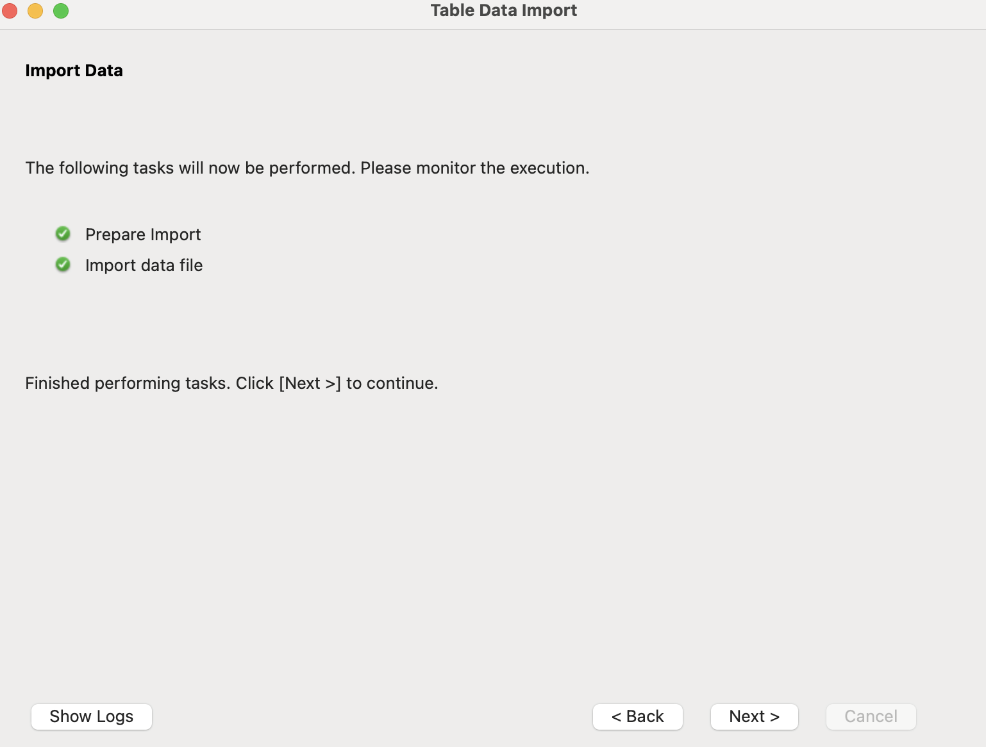

Step4: After the import process was completed, I verified the data in the Staging_Demographics_1 table to ensure that the records were successfully imported.

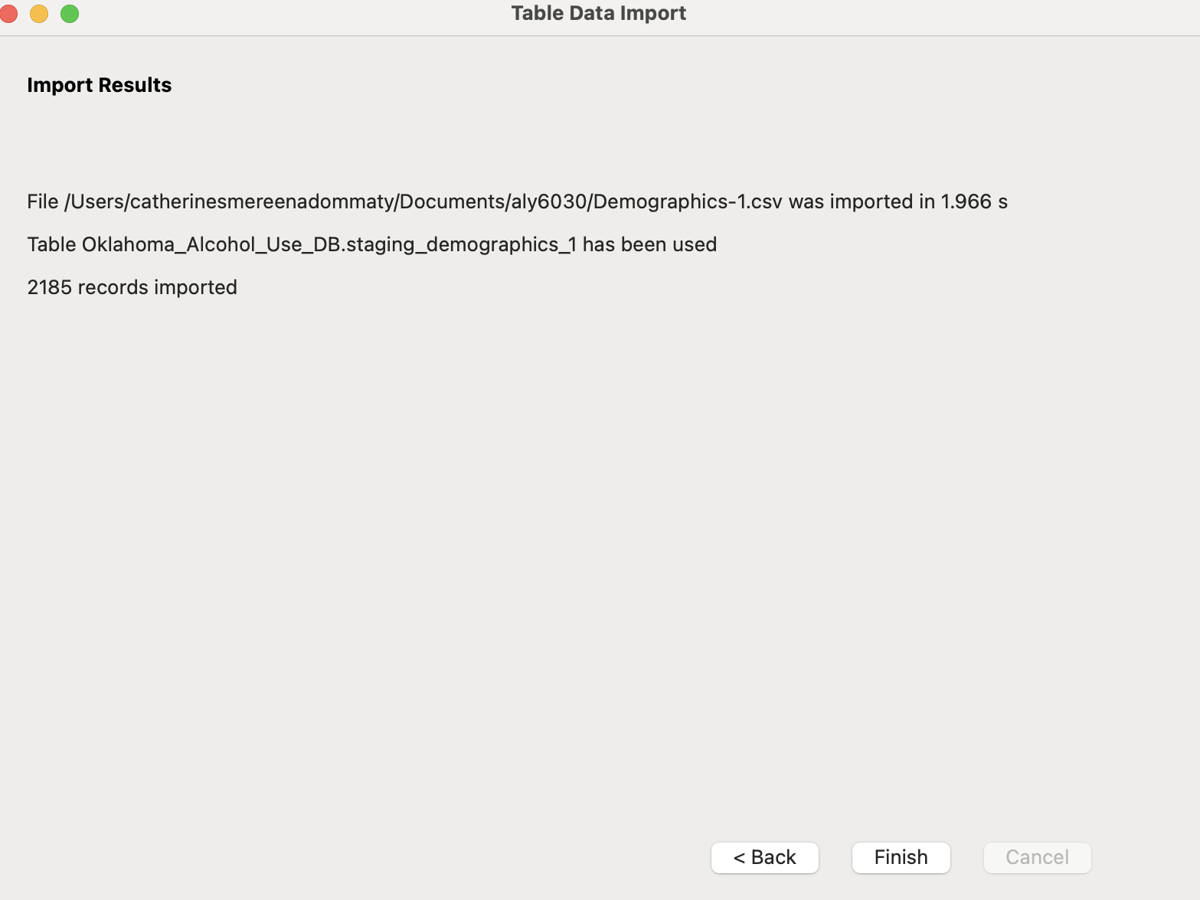

**Step1: Inserting Data into Dim_Question Table**

After creating the Dim_Question table, the first step was to populate it with distinct questions from the raw BRFSS data stored in the Staging_BRFFS_OK table. This ensures that each question is uniquely identified in the Dim_Question table.

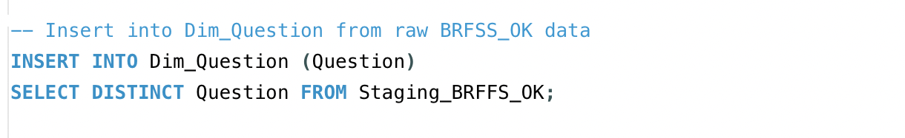

This query inserts unique survey questions into the Dim_Question table from the Staging_BRFFS_OK table.

By using the DISTINCT keyword, only unique questions are inserted, ensuring there are no duplicates in the Dim_Question table.

This step is important to ensure that the Dim_Question table holds a clean set of survey questions for use in the analysis.

**Step2:Creating the Dim_Response Table**

The next step was to create the Dim_Response table, which stores the possible responses to the BRFSS survey questions, such as "Yes" or "No."

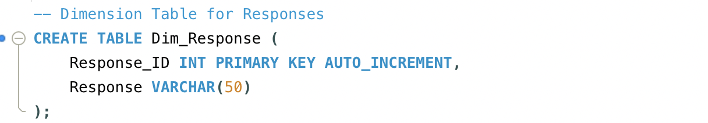

The Dim_Response table is created to hold unique responses provided by survey participants.

The table has two columns: Response_ID, which is an auto-incrementing primary key, and Response, which stores the actual response values.

The Response_ID will be used as a foreign key in the Fact_Alcohol_Use table to link responses to their corresponding records.

**Step 3: Inserting Data into Dim_Response Table**

Once the Dim_Response table was created, the next step was to insert unique responses from the Staging_BRFFS_OK table. This table contains raw survey data, including responses such as "Yes" or "No."

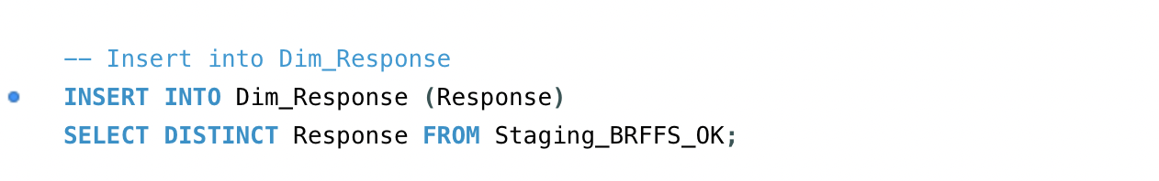

This query populates the Dim_Response table with distinct responses from the Staging_BRFFS_OK table.

The use of the DISTINCT keyword ensures that only unique responses are inserted, avoiding any duplicate entries.

This step helps in standardising the responses in the Dim_Response table, which will be referenced in the fact table for analysis.

**Step 4: Creating the Dim_Location Table**

Next, I created the Dim_Location table, which stores geographic information such as ZipCode, City, and County. This dimension table allows for analysis based on the location of the survey respondents.

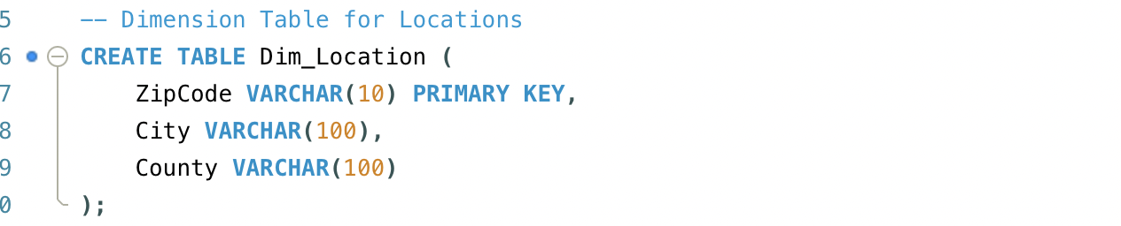

The Dim_Location table is designed to hold location data, specifically ZipCode, City, and County.

Each ZipCode serves as the primary key, ensuring that each location is uniquely identified in the table.

This table will be used to associate respondents' geographic data with their survey responses in the Fact_Alcohol_Use table.

**Step 5: Inserting Data into Dim_Location Table**

Once the Dim_Location table was created, I inserted distinct location data from the Staging_Demographics_OK table. This table contains the raw demographic data for Oklahoma, including ZipCode, City, and County.

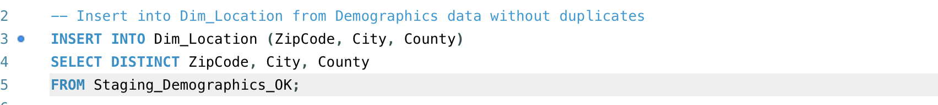

This query populates the Dim_Location table with unique geographic entries from the Staging_Demographics_OK table.

The DISTINCT keyword ensures that only unique combinations of ZipCode, City, and County are inserted into the Dim_Location table, preventing any duplicate location records.

This table will enable the analysis of survey data based on different geographic regions.

**Creating and Populating Dimension and Fact Tables**

**Step 1: Creating the Dim_Location Table**

The first step involves creating the Dim_Location table, which holds information about geographic data such as ZipCode, City, and County. This table will be linked to the fact table to allow geographic-based analysis.

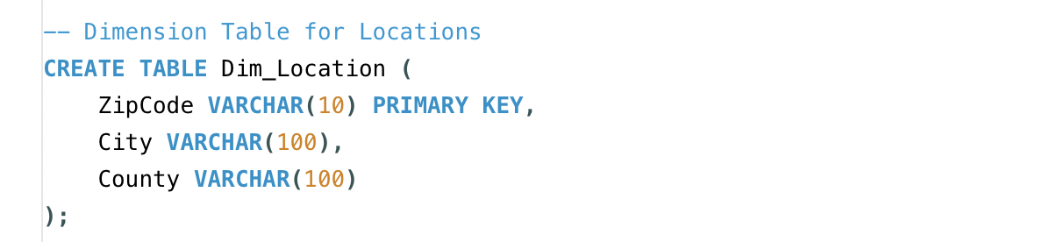

The Dim_Location table is designed to store geographic data for each respondent.

The ZipCode serves as the primary key, ensuring that each geographic location is uniquely identified.

**Step 2: Inserting Data into the Dim_Location Table**

After creating the Dim_Location table, the next step was to populate it with unique records from the Staging_Demographics_OK table. This table contains raw demographic data, including ZipCode, City, and County.

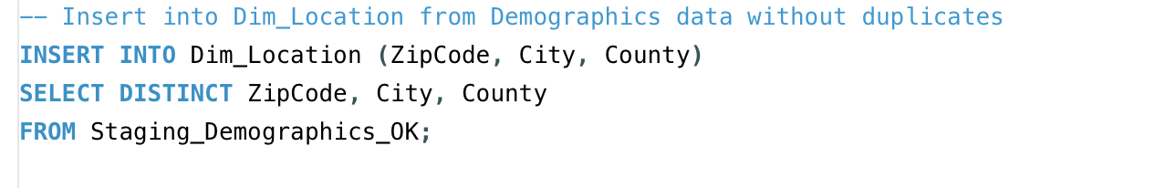

This query inserts distinct geographic data from the staging table into the Dim_Location table.

The use of the DISTINCT keyword ensures that only unique combinations of ZipCode, City, and County are inserted into the table, avoiding duplicates.

**Step 3: Creating the Dim_Break_Out Table**

Next, I created the Dim_Break_Out table, which stores demographic details such as the age group of respondents (e.g., "18-24"). This table will later be linked to the fact table to analyse alcohol use by demographic breakdowns.

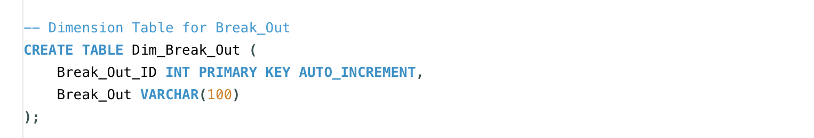

The Dim_Break_Out table holds data on demographic groups (e.g., age group), which is useful for analysing alcohol use across different demographic categories.

The Break_Out_ID is auto-incremented to serve as a unique identifier for each demographic group.

**Step 4: Inserting Data into the Dim_Break_Out Table**

After creating the Dim_Break_Out table, the next step was to populate it with unique records from the Staging_BRFFS_OK table, which contains demographic data for respondents.

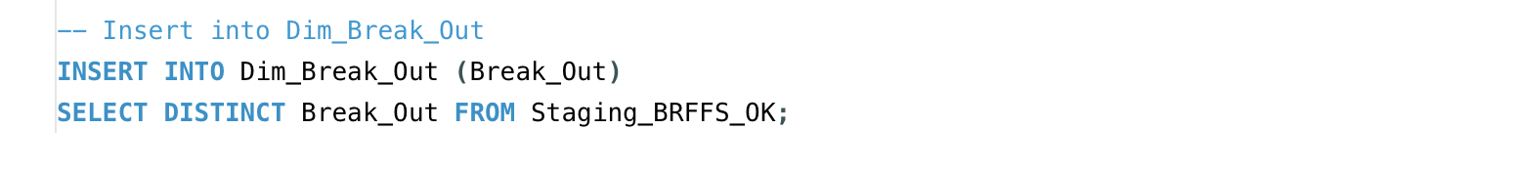

This query inserts distinct demographic breakdowns from the Staging_BRFFS_OK table into the Dim_Break_Out table.

The use of DISTINCT ensures that only unique values are inserted, which prevents duplicates.

**Step 5: Creating the Dim_Break_Out_Category Table**

The next step was to create the Dim_Break_Out_Category table, which provides additional demographic classifications such as income levels, education, or employment status.

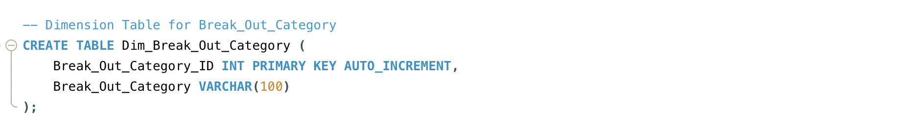

The Dim_Break_Out_Category table stores demographic categories, which provide an additional layer of demographic information beyond the basic breakout groups.

The Break_Out_Category_ID is auto incremented to serve as a unique identifier for each demographic category.

**Step 6: Inserting Data into the Dim_Break_Out_Category Table**

After creating the Dim_Break_Out_Category table, the next step was to populate it with unique records from the Staging_BRFFS_OK table, which contains data about demographic categories.

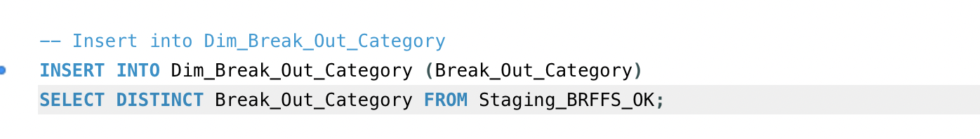

This query inserts distinct demographic categories from the Staging_BRFFS_OK table into the Dim_Break_Out_Category table.

The use of DISTINCT ensures that only unique values are inserted, preventing duplicates.

**Step 7: Creating the Fact_Alcohol_Use Table**

After the dimension tables were populated, I proceeded to create the Fact_Alcohol_Use table. This table is the central fact table in the star schema and stores quantitative data about alcohol consumption, including Sample_Size and Data_Value.

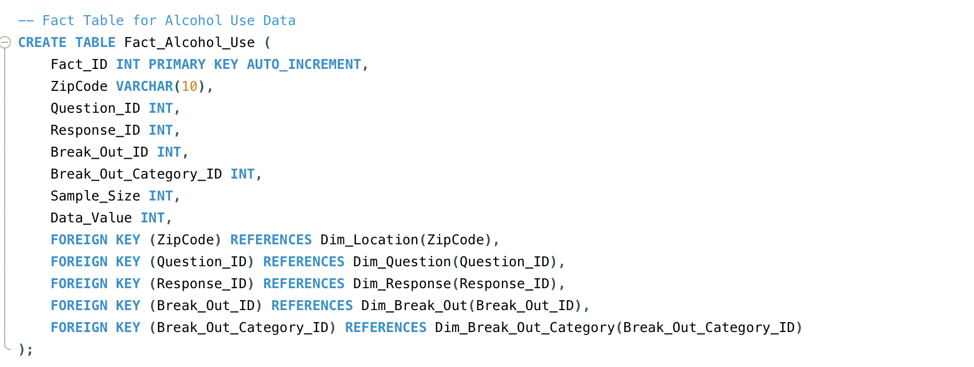

The Fact_Alcohol_Use table holds the main data related to alcohol consumption, including the number of respondents (Sample_Size) and how many reported drinking (Data_Value).

This table is linked to the dimension tables via foreign keys, allowing for the analysis of alcohol use by geographic location, survey question, response, demographic breakout, and category.

**Establishing Foreign Key Relationships**

Each foreign key in the Fact_Alcohol_Use table establishes a relationship with the corresponding dimension table:

**Foreign Key (ZipCode):** Links the Fact_Alcohol_Use table to the Dim_Location table, allowing analysis by geographic location.

**Foreign Key (Question_ID):** Links to the Dim_Question table, enabling analysis based on the survey questions.

**Foreign Key (Response_ID):** Links to the Dim_Response table, facilitating analysis based on the responses to the questions.

**Foreign Key (Break_Out_ID):** Links to the Dim_Break_Out table, enabling analysis of data based on demographic groups like age.

**Foreign Key (Break_Out_Category_ID):** Links to the Dim_Break_Out_Category table, allowing further breakdown of the demographic data.

**Step:8 Inserting Data into Fact_Alcohol_Use Table**

The first step involves inserting the data from the Staging_BRFFS_OK table into the Fact_Alcohol_Use table. This step also involves mapping the data to the appropriate IDs from the dimension tables. Here's how the insertion is done:

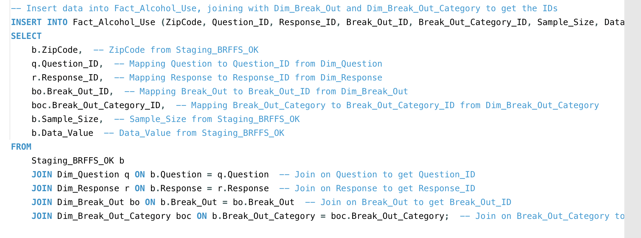

The Fact_Alcohol_Use table is populated by selecting data from the Staging_BRFFS_OK table.

The data is joined with dimension tables (Dim_Question, Dim_Response, Dim_Break_Out, and Dim_Break_Out_Category) to retrieve the respective IDs and populate the fact table with their values.

This process ensures that the fact table contains the necessary foreign key references to each dimension, linking the survey data (question, response, demographics) with the quantitative metrics (sample size and data value).

**Step9: Dropping Staging Tables**

Once the data has been successfully inserted into the Fact_Alcohol_Use table and is linked to the dimension tables, it’s time to clean up by dropping the staging tables. These tables were used only for initial data loading and transformation and are no longer needed.

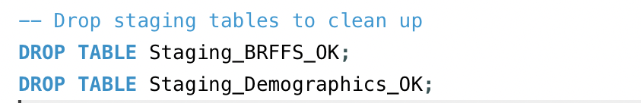

The Staging_BRFFS_OK and Staging_Demographics_OK tables were used to temporarily hold the raw data for processing and normalisation.

After the data has been transformed and inserted into the fact and dimension tables, the staging tables are no longer needed.

Dropping these tables frees up space and prevents confusion in the future as only the final, processed tables will remain in the database.

**The Query to Identify Highest and Lowest Alcohol Abuse by City and County for Age Group 18-24**

Step 1: Analysing Alcohol Abuse by City for Age Group 18-24

This step involves writing a query that calculates the highest and lowest alcohol abuse by City for the age group 18-24. The calculation is based on the ratio of the Data_Value (number of respondents who admitted alcohol consumption) to the Sample_Size (total number of respondents in that age group).

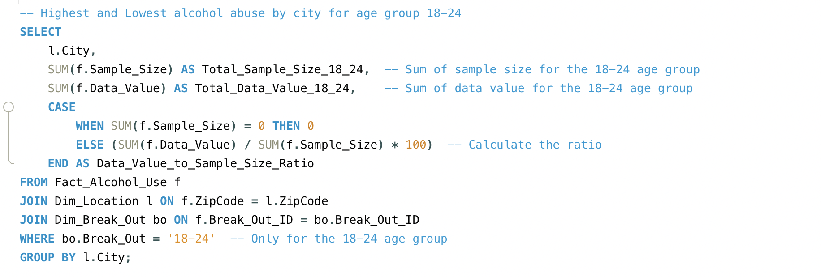

This query groups the results by City and calculates the total number of respondents in the 18-24 age group (Sample_Size) and the total number of respondents who admitted alcohol use (Data_Value).

The Data_Value_to_Sample_Size_Ratio column calculates the percentage of alcohol abuse in each city by dividing the total Data_Value by the total Sample_Size and multiplying by 100.

The Fact_Alcohol_Use table is joined with the Dim_Location table to get the City name and with Dim_Break_Out to filter results for the age group 18-24.

Group by city: The query groups the results by City, calculating the sum of the sample size and the number of respondents for each city.

Calculate ratio: For each city, the query calculates the percentage of respondents in the age group 18-24 who admitted to alcohol consumption.

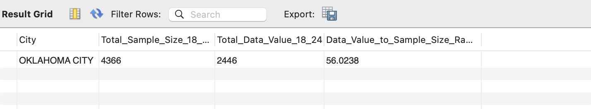

The query returns the list of cities with the total sample size, total alcohol use data, and the percentage of alcohol use for the age group 18-24.

**Analysing Alcohol Abuse by County for Age Group 18-24**

In this step, I execute a similar query, but the results are grouped by County instead of City. This will help analyse alcohol abuse trends at a county level for the 18-24 age group.

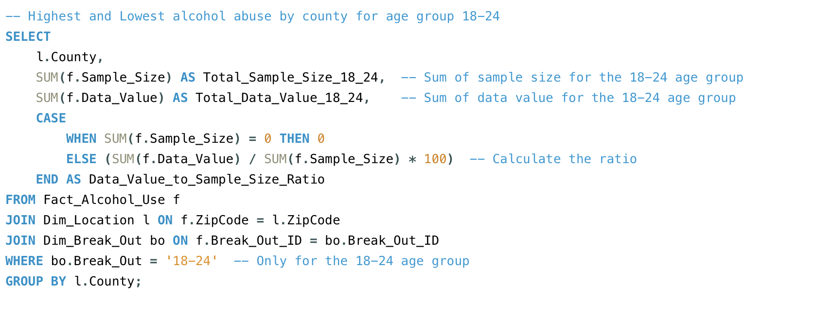

This query calculates the percentage of alcohol abuse by county for the age group 18-24, like the query for cities, but grouped by County.

It provides the total sample size, the total number of respondents who admitted to alcohol use, and the percentage of alcohol use for each county.

Join the tables: The Fact_Alcohol_Use table is joined with the Dim_Location table to get the County name and with Dim_Break_Out to filter the data for the age group 18-24.

Group by county: The query groups the results by County, calculating the sum of the sample size and the number of respondents who admitted alcohol consumption for each county.

Calculate ratio: For each county, the query calculates the percentage of respondents who admitted alcohol consumption by dividing Data_Value by Sample_Size and multiplying by 100.

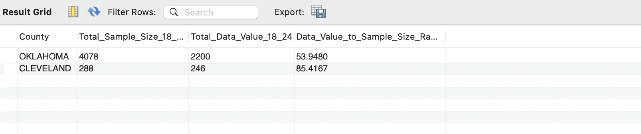The query returns the list of counties with the total sample size, total alcohol use data, and the percentage of alcohol use for the age group 18-24.

**Conclusion:**

The primary goal of this project was to analyse alcohol consumption patterns among adolescents aged 18-24 in Oklahoma, specifically by city and county, using the available BRFSS data. The expectation was to identify geographic regions with the highest and lowest rates of alcohol abuse, enabling targeted interventions and public health strategies.

**Goals and Expectations Met**

The SQL queries successfully identified the cities and counties where alcohol abuse is more prevalent among young adults. The data was accurately transformed, stored, and analysed using a star schema, which made querying and analysing data from different dimensions more efficient.

**Challenges and Limitations**

However, there were some challenges related to data availability and completeness. Certain locations may have had limited responses in the BRFSS dataset, which could affect the precision of the findings.

**Pros and Cons of Tools, Methods, and Techniques**

**Pros:**

Star Schema Design: Provided a clear, organised structure for storing the data, making querying, and analysing data from multiple dimensions straightforward.

MySQL Workbench: User-friendly for importing large datasets and running queries, with the ability to quickly visualise relationships between tables.

SQL Queries: Efficiently calculated alcohol abuse rates by city and county, with the ability to aggregate data and calculate ratios directly in SQL.

**Cons:**

Data Limitations: The BRFSS dataset may have gaps or uneven distribution of responses across cities and counties, which could skew the results and limit the generalizability of the findings.

Manual Data Cleaning: Handling missing data or inconsistencies in the raw dataset required manual intervention during the data import and staging process.

Staging and Dropping Tables: Managing and dropping staging tables could be simplified with more automated data pipeline tools.

Future Directions

Automation of ETL Processes: Implement a more automated ETL process to streamline the data import and transformation steps, reducing the chance of errors and speeding up the process.

Incorporate More Advanced Analytics: Explore more advanced statistical or machine learning methods to identify deeper patterns or correlations in the data.

Improve Data Quality Checks: Implement more robust data quality checks during the data import phase to ensure the accuracy and consistency of the dataset.

Additional Data Sources: Incorporate additional data sources to provide a more comprehensive view of the factors influencing alcohol use in certain regions.

In conclusion, the project met its core goals of analysing adolescent alcohol use by city and county in Oklahoma. The star schema design and SQL queries were effective for storing, organising, and analysing the data. However, there is room for improvement, especially in automating the data pipeline, incorporating more advanced analytics, and improving data quality checks.

**References:**

W3Schools. (n.d.). SQL tutorial. W3Schools. Retrieved October 16, 2024, from <https://www.w3schools.com/sql/default.asp>